

DRAFT [Installation Name] Installation
Energy and Water Plan

[Update Date]

DRAFT [Installation Name] Installation Energy and Water Plan

[Update Date]

Prepared with support from [Name of Laboratory and/or Contractor Producing this Report] under contract with the Office of the Deputy Assistant Secretary of the Army for Energy & Sustainability. [Report number]

Garrison Commander’s Signature Page
DEPARTMENT OF THE ARMY
HQ, [Installation Name]
[ADDRESS]
[DATE]

History: N/A – First Release
Summary: This is the initial release of the JBLM Installation Energy and Water Plan, as required per DoD Memorandum, 31 March 2016 (“Installation Energy Plans”) & OACSIM “Guidance for Installation Energy and Water Plans (IEWPs)” 26 July 2018
Applicability: This plan applies to all Active Army, U.S. Air Force, Army National Guard organizations, and DA Civilians assigned or attached to JBLM. It further applies to all Department of Defense organizations, other Federal organizations, state and local, and privatively owned organizations resident at JBLM.
Proponent and exception authority: The proponent for this publication and planning activity is the JBLM Directorate of Public Works.
Army management control process: This publication does not contain management control provisions.
Supplementation: Supplementation of this publication is prohibited without prior approval from the Records Management Division, Publications and Forms Manager (FMO)
Suggested Improvements: Users are invited to send comments and suggested improvements on DA Form 2028
(Recommended Changes to Publications and Blank Forms) to DPW, JBLM (IMNW-LEW-PW)

FOR THE COMMANDER:
OFFICIAL:

SKYE D. DUNCAN
COL, AR
Commanding

[OTHER signatories as needed -e.g., CSM Timothy Marble, Deputy DPW, Chief of Staff?]

STEVEN T. PERRENOT
Director of Public Works

Distribution:
For Official Use Only (FOUO). This publication is only available in electronic media.

Acronyms and Abbreviations
[Template Note: The acronyms included are those that will be used in all IEWPs. Site specific acronyms may need to be added.]

AA assured access
ACSIM Assistant Chief of Staff for Installation Management
AEWRS Army Energy and Water Reporting System
AR Army Regulation
ASA IE&E Assistant Secretary of the Army for Installations, Energy and Environmental
BAS building automation system
BEI baseline element of information
BCT Brigade Command Team
CDD cooling degree days
CIP capital improvement plan
CMRR Critical Mission Risk Reduction
CMS critical mission sustainment
COA course of action
CY calendar year
DCA Defense Critical Asset
DES Directorate of Emergency Services
DoD U.S. Department of Defense
DPTMS Directorate of Plans, Training, Mobilization and Security
DPW Directorate of Public Works
DTIC Defense Technical Information Center
E&W energy and water
ECM energy conservation measures
EEDRS Enterprise Energy Data Reporting System
EM Emergency Management
EO Executive Order
EOC emergency operations center
ERCIP Energy Resilience and Conservation Investment Program
ERP emergency response plan
ESPC energy savings performance contract
ESTCP Environmental Security Technology Certification Program
EUI energy use intensity
FEDS Federal Energy Decision System
FY fiscal year
GC Garrison Commander
GIS geographic information system
HQ headquarters
HQDA Headquarters, Department of the Army
HVAC heating, ventilation, and air conditioning
IC infrastructure condition
ICS industrial control system
IEWP Installation Energy and Water Plan
IMCOM Installation Management Command
IRR installation risk reduction
ISR-MC Installation Status Report – Mission Capacity
IT information technology
LED light-emitting diode
LNG liquefied natural gas
LRC Logistics Readiness Center
MDMS Meter Data Management System
MFGI Mobilization Force Generation Installation
MGD million gallons per day
MILCON military construction
NEC Network Enterprise Center
O&M operations and maintenance
OCA Original Classification Authority
POL petroleum, oil, and lubricants
PV photovoltaics
QUTM utilities modernization
R&R repair and replacement
SCG security classification guide
SIPRNet Secret Internet Protocol Router Network
SIR savings to investment ratio
SO system operation
SRM sustainment, restoration, and modernization
TCA Task Critical Asset
UESC utility energy savings contract
UFC Unified Facilities Criteria
UMCS Utility Monitoring and Control Center
UP utility privatization
WUI water use intensity

Contents
Garrison Commander’s Signature Page iii
Acronyms and Abbreviations iv
1.0 Introduction 1
2.0 Critical Mission Overview 2
3.0 Risk Assessment 4
3.1 Critical Mission Sustainment 4
3.1.1 Electricity 4
3.1.2 Natural Gas 5
3.1.3 Other Utilities, as needed 5
3.1.4 Water and Wastewater 5
3.2 Critical Mission Risk 6
3.2.1 Electricity 6
3.2.2 Natural Gas 7
3.2.3 Other Utilities, as needed 7
3.2.4 Water and Wastewater 7
3.3 Installation Risk 8
3.3.1 Energy 9
3.3.2 Water 11
4.0 Implementation Plan 13
5.0 Tracking Progress 15
6.0 References 16
Appendix A – Planning Process A.1
Appendix B – Critical Facilities B.1
Appendix C – Baseline Conditions and Risk Assessment C.1
Appendix D – Courses of Action Considered D.13
Appendix E – Implementation Plan Development E.1
Appendix F – CLASSIFIED Findings F.1

Figures
Figure 1. [Installation Name] Energy Use Intensity Performance 10
Figure 2. [Installation Name] Energy Utility Costs 10
Figure 3. [Installation Name] Water Use Intensity Performance 12
Figure 4. [Installation Name] Water Utility Costs 12

Tables
Table 1. Count of Critical Facilities by Category 2
Table 2. Critical Facilities Assessed and Supporting Critical Missions 3
Table 3. Electricity System Deficiencies and Estimated Count of Facilities and Critical Missions Affected 6
Table 4. Natural Gas System Deficiencies and Estimated Count of Facilities and Critical Missions Affected 7
Table 5. Water and Wastewater System Deficiencies and Estimated Count of Facilities and Critical Missions Affected 8
Table 6. Deficiencies Defined by [Insert FY of most recent ISR-MC] ISR-MC Energy Measures 9
Table 7. Deficiencies Defined by [Insert FY ISR-MC metrics are from] ISR-MC Water Measures 11
Table 8. [Installation Name] Energy & Water Security Implementation Plan 14

Introduction
The [Installation Name] Installation Energy and Water Plan (IEWP) provides a roadmap for achieving increased security, resilience, readiness, and mission assurance, while also meeting federal and Department of Defense (DoD) requirements. This IEWP provides the goals, strategies, tasks, timeline, and responsible parties for the next 5 years of energy and water (E&W) management at [Installation Name]. The planning process and resulting roadmap follow Army and DoD guidance.
The primary goals of the [Installation Name] IEWP are as follows:
- Ensure the ability of [Installation Name] to sustain critical missions in the event of an energy and/or water service disruption.
- Reduce the risk to all critical missions from E&W (including wastewater) disruptions, with priority given to the [Insert missions with priority, if any].
- Reduce use of E&W resources across the installation.
- Increase installation operational efficiency.
In pursuing these goals, [Installation Name] leadership has stated the importance of strategies that consider the following:
[Template Note: The list below is included as an example. Each site may place different priority on implementation strategies.]
- Provide cost-effective alternatives to generators (e.g., storage, photovoltaics [PV], demand-response).
- Help to manage responses from the electric utility to reduce load under an interruptible tariff notice.
- Leverage alternative funding to support project implementation.
- Leverage Privatized Utility Capital Improvement Plan projects for smart modernization.
- Consider the operations and maintenance (O&M) requirements of recommended solutions.
This document is organized to concisely present the installation’s plan. The plan provides an overview of the critical mission facilities at [Installation Name] (Section 2.0), the E&W security baseline and deficiencies identified (Section 3.0), and strategies for achieving installation goals and addressing those deficiencies. Priority tasks aligned with these strategies are summarized in an installation implementation plan (Section 4.0). The assessment process is described in Appendix A; facilities supporting critical missions are found in Appendix B; findings from the assessment of baseline conditions and deficiencies are found in Appendix C; and detailed courses of action considered are summarized in Appendix D. Appendix E contains implementation plan development background and details. Appendix F, which will be transmitted to [Installation Name] separately via SIPRNet, contains classified findings from the assessment, and must be maintained on a computer system with appropriate information security controls.
The [Installation Name] IEWP is a living document, structured around a prioritized list of tasks over a 5-year planning horizon (Section 5.0). The [Installation Name] DPW has primary ownership of this plan, but requires the assistance of other [Installation Name] directorates and mission owners to ensure tasks are completed. [Installation Name] will review the IEWP each year and adjust it as needed. A full plan update will occur every 5 years.

Critical Mission Overview
[Template Note: The first two paragraphs are provided as an example of the level of detail. Key information to include is a brief overview of the site, as indicated in the first paragraph, and then a summary of the site’s mission.]
[Replace paragraph—sample of detail only] Site, State, is the second-largest U.S. Army installation in land area. It is the home to the 1st Armored Division (1 AD)…and other units. The post has xxx million acres of land that stretches from the western tip of xxx north into xxxx. The main cantonment area is in city, state. It is home to xxx military personnel and another xxx family members, and employs xxx civilians.
[Replace paragraph with information on the installations mission(s)—sample of detail only] XXX’s mission is to ensure the readiness of the power projection platform and provide training, mobilization, deployment, and sustainment support in support of the world’s best trained war fighters. XXX provides state-of-the-art facilities to support the full spectrum of training requirements of today’s modern armed forces. Installation lands and ranges provide excellent training opportunities for mechanized maneuver and small unit exercises, combined arms training, and live-fire training.
To establish the garrison’s ability to sustain its critical missions with E&W resources, and to manage risk of E&W utility disruptions, critical mission areas are mapped to facilities and infrastructure. For this mapping, key facility definitions are as follows:
- Critical – A facility that is directly tied to a critical mission and requires energy and/or water to support that mission. Critical facilities can be of two types:
- Non-critical – A facility that is important to overall installation operations, but utility interruption would not have a significant impact on critical missions.
A total of [Insert number of critical facilities] facilities comprise the critical facilities list at [Installation Name] (Table 1). To focus the assessment, [Insert number of facilities evaluated] of these critical facilities were targeted for detailed facility-level reviews for deficiencies and opportunities during the development of this IEWP. This included those most dependent on E&W resources (the biggest users) and excluded some redundant facility types (e.g., dining facilities, access control points) with relatively predictable/consistent E&W demand and use patterns, and functions that can be easily moved during an outage. [If applicable, include information on specific facilities that were excluded from evaluation and why.]
Table 1. Critical Facilities
Critical Mission Owner | Count of Facilities/Count of Facilities Assessed | Facilities (Building Numbers) | General Facility Function/Description
 | /
 | /
 | /

Risk Assessment
This IEWP is based on a detailed assessment of [Installation Name]’s operational requirements, baseline conditions, deficiencies/opportunities and associated risk, and potential solutions to manage those risks. Following the Army’s draft Installation Energy and Water Security Assessment Guide (see Appendix A), the risk assessment identified E&W security and resilience gaps, deficiencies, and opportunities in three key areas:
- Critical mission sustainment (CMS) – Establish whether facilities with little or no tolerance for energy and/or water disruption have the E&W needed to sustain operations under all operating conditions. [Installation Name] established the CMS minimum duration at be [#] days.
- Critical mission risk reduction (CMRR) – Identify deficiencies related to infrastructure condition, lack of redundancy, and infrastructure exposure specifically in, or directly connected to, critical facilities.
- Installation risk reduction (IRR) – Establish general risk to the installation from inadequate operational procedures and plans, overall E&W infrastructure condition, and availability/access to E&W resources to support installation-wide needs. The installation risk assessment used Installation Status Report–Mission Capacity (ISR-MC) ratings as a proxy. It also identified inefficient use of E&W resources in all installation facilities as deficiencies.
The specifics of each risk assessment are described, in the order listed above, in the following subsections (3.1, 3.2, and 3.3) and are organized by utility. Note that all counts of critical facilities with deficiencies represent the minimum number of facilities affected, since only a subset [Insert number of facilities assessed and total number of critical facilities] of the critical facilities were assessed for deficiencies.

Critical Mission Sustainment
The CMS risk analysis was conducted to evaluate the installation’s onsite resource availability to sustain critical missions for a long-term disruption. The [CMS duration]-day CMS target (validated by mission owners) is only applicable to the critical facilities at an installation. The assessment team conducted the CMS risk analysis for [#] critical facilities identified at [Installation Name]. CMS risk analysis results are summarized in this section, details on the risk assessment process are provided in Appendix A, and detailed results are provided in Appendix C.

Electricity
Key risk factors for meeting the CMS requirement for electricity include 1) the availability of a backup or continuous power source to the critical facilities, and 2) the availability of adequate fuel or energy storage to supply the power source for the [CMS duration]-day CMS period. To meet the fuel storage requirement when generators are used, the fuel must be available onsite or firm plans for refueling the generator must be in place for the facility.
At [Installation Name], [#] of [#] of the critical facilities assessed (#%) have generators in place, and none have an alternative source providing continuous long-term power. Of those with generators, most will run just [#] to [#] days before available onsite fuel stores are depleted. Currently, only [#] of the [#] critical facilities assessed can meet the long-term CMS requirement with onsite fuel storage. None of those facilities without adequate onsite storage had firm plans in place for refueling to ensure [CMS duration] days of continuous runtime.
An estimated [Insert gallons of fuel needed to meet CMS requirement] gallons of diesel fuel are required to meet the CMS requirement for all [#] critical facilities assessed. Currently, there [is no/is] bulk diesel storage dedicated to generators at [Installation Name]. It should be noted that [Insert number of generators that run on natural gas – if none, delete this and the next sentence. Also edit the last sentence as applicable] of the generators on critical facilities run on natural gas. While these have the potential to sustain operations with a continuous flow of gas, they do not meet the CMS requirement as defined in the policy due to the lack of onsite gas storage. See Appendix C, Section C.3.5, for details.

Natural Gas
[This is an example. Revise as needed.] The key risk factor for meeting the CMS requirement is the lack of natural gas storage onsite at [Installation Name]. Natural gas is used for backup power in [#] critical facilities, which would require gas storage for [CMS duration] days or dual fuel capable equipment to meet the CMS requirement. Natural gas is also used for backup generators at [#] critical facilities, and for building heat and hot water in both critical and non-critical facilities.
[This is an example. Revise as needed.] While the probability of occurrence is low, in the event of a concurrent power and natural gas outage at the installation, the critical—interruptible buildings that rely on natural gas backup generators would also experience power outages. As a result, this is considered a CMS deficiency. (See Appendix C, Section C.4.5 for details on this analysis.)

Other Utilities, as needed

Water and Wastewater
Key risk factors for meeting the CMS requirement for water include the availability of the following:
- Sufficient onsite water to support critical facilities
- Onsite supplies, equipment, and staff to treat the water to ensure that water is potable at critical facilities
- Backup power or a continuous power source (e.g., PV with energy storage) at all water supply, distribution, and treatment facilities and wastewater pumping facilities to run for [CMS duration] days
- Fuel and fueling capabilities onsite to refuel any backup power sources that serve water supply, distribution, and treatment equipment, and wastewater pumping facilities; refueling plans that aren’t documented and exercised annually are considered a deficiency.
Water systems are heavily dependent on power for supply, distribution, and treatment of drinking water and pumping wastewater. Lack of power to water system equipment can result in lack of water and wastewater services to critical facilities. Subsequent lack of water to any facility at the installation can result in mandatory building closures in as little as 2 hours, based on interviews with environmental health professionals. In addition, sewer backups or overflows in buildings due to inoperable lift stations can also result in immediate mandatory building closures. Mandatory building closures are the result of unsanitary and unsafe working conditions due to lack of drinking water and/or restroom facilities and are determined regardless of building criticality.
[Template Note: The water and wastewater should include the number of facilities assessed, any issues identified in the assessment that could result in water unavailability, to what extent water/wastewater is impacted during a power outage, and the effectiveness of backup power to resolve water issues during an outage. The paragraphs below are provided as examples. Write and revise as needed.]

Critical Mission Risk
The critical mission risk analyses were conducted for the [Insert number of critical facilities] critical facilities identified at [Installation Name] for inclusion in this analysis. Key risks for E&W disruptions to critical missions come from deficiencies in infrastructure condition, lack of redundancy, and exposure when that infrastructure directly supports a critical facility. When coupled with the prevalent natural hazards described in Appendix C, Section C.2, and other threats or hazards that may be identified through the critical infrastructure risk management process, these deficiencies create critical mission risk.

Electricity
Risks to critical missions from electricity infrastructure deficiencies at [Installation Name] are summarized in Table 2. The count of critical facilities with each deficiency and missions affected by these deficiencies provides some indication of the extent of the risk. The association of specific critical facilities and deficiencies is treated as classified and is detailed in Appendix F, CLASSIFIED Findings.
[Template Note: The paragraph below provides examples of deficiencies that may be present at an installation. Information specific to the installation the IEWP is being written for should be provided.]
As shown in Table 2, a significant number of facilities have unknown electrical system redundancy. Circuit maps and one-line diagrams were not available to verify where redundancy of circuits and feeders currently exists, and whether transformer sizes are adequate for interconnection. Power quality issues were verified with utility reports and are a concern as power spikes and sags can place sensitive mission equipment at risk for damage. The lack of backup power to critical facilities, including to critical water infrastructure that requires power for chlorination to meet portability requirements, is a deficiency affecting a significant number of facilities. For facilities with backup generators, refueling plans are lacking. Finally, the main substation is near capacity with connected loads, posing a risk to a number of critical facilities.

Table 2. Electricity System Deficiencies and Estimated Count of Facilities and Critical Missions Affected
 |  | Missions Affected
Deficiency | Count of Critical Facilities | Critical Mission 1 | Critical Mission 2 | Critical Mission 3 | Critical Mission 4 | Critical Mission 5 | Etc.
Deficiency Description | # | X | X |  | X | X | X | X | X | X |  | X | X |  | X |  | X | X | X | X | X | X |  | X |  | X | X

Natural Gas
Risks to critical missions from natural gas infrastructure deficiencies at [Installation Name] are summarized in Table 3. The count of critical facilities with each deficiency and missions affected by these deficiencies provides some indication of the extent of the risk. The association of specific critical facilities and deficiencies is treated as classified and is detailed in Appendix F, CLASSIFIED Findings.
[Template Note: The paragraph below provides example description of deficiencies that may be present. Information specific to the installation the IEWP is being written for should be provided.]
The most critical function that natural gas supports on the installation is backup generation at [##] facilities, including backup for water pumps. While the probability of a simultaneous gas and electric outage may be low, the lack of onsite gas storage to supply these generators is considered a deficiency. Other deficiencies include single gas mains, dead-end gas distribution lines, and distribution lines that are both in poor condition and exposed to the elements. These risks to critical missions from natural gas infrastructure deficiencies and lack of natural gas backup sources are summarized in Table 3. Specific facilities affected are treated as classified information and can be found in Appendix F, CLASSIFIED Findings.
Table 3. Natural Gas System Deficiencies and Estimated Count of Facilities and Critical Missions Affected
 |  | Missions Affected
Deficiency | Count of Critical Facilities | Critical Mission 1 | Critical Mission 2 | Critical Mission 3 | Critical Mission 4 | Critical Mission 5 | Etc.
Deficiency Description | # | X | X |  | X | X | X | X | X | X |  | X | X |  | X |  | X | X | X | X | X | X |  | X |  | X | X

Other Utilities, as needed

Water and Wastewater
Risks to critical missions from a lack of backup power for water and wastewater infrastructure and other infrastructure deficiencies at [Installation Name] are summarized in Table 4. Specific facilities affected are treated as classified information and can be found in Appendix F, CLASSIFIED Findings.
[Template Note: The paragraph below provides example description of deficiencies that may be present. Information specific to the installation the IEWP is being written for should be provided.]
General deficiencies affecting most missions include the lack of backup power to critical pieces of water infrastructure that supply potable water to facilities, and a lack of plans to provide potable water and portable toilets to critical facilities should a water or wastewater outage occur. The condition of wells and booster stations supporting numerous critical facilities has been identified as poor and fair, and distribution line condition for portions of the installation is not known, representing a risk. Key wastewater system deficiencies include several lift stations without bypasses to prevent sewer overflows, backups, and subsequent building closures.

Table 4. Water and Wastewater System Deficiencies and Estimated Count of Facilities and Critical Missions Affected
 |  | Missions Affected
Deficiency | Count of Critical Facilities | Critical Mission 1 | Critical Mission 2 | Critical Mission 3 | Critical Mission 4 | Critical Mission 5 | Etc.
Deficiency Description | # | X | X |  | X | X | X | X | X | X |  | X | X |  | X |  | X | X | X | X | X | X |  | X |  | X | X

Installation Risk
The ISR-MC indicates an installation’s level of risk exposure to an energy or water disruption, as well as the capability of an installation to sustain critical mission activities during a disruption. The report is categorized across four attributes defined in Army Directive 2017-07. Each attribute has multiple measures, which can be rated as green+ or green (best), amber, red, or black (worst).
ISR-MC measures rated as amber, red, or black are considered an installation risk. A complete list of ISR-MC measures, possible measure responses, [Installation Name] responses, and a more detailed explanation of deficiencies can be found in Appendix C, Section C.3.4, C.4.4, and C.5.4.
A second indictor of installation risk for E&W resilience is E&W use efficiency in all installation facilities. Performance against historical installation-level E&W reduction targets and utility cost trends are also presented below.
A third aspect of installation risk involves the resiliency of information technology (IT) and operational technology (OT) systems. These complex systems are vulnerable to both physical and computer-based attacks. To address cyber risk, the individual systems and the supporting network infrastructure must be assessed. Reducing cybersecurity risk is paramount to improving installation resiliency. Cyber installation risk is addressed in Appendix C, Section C.6.

Energy
Of the total ISR-MC energy metrics reported in [Insert FY of most recent ISR-MC], [Installation Name] had deficiencies in [Insert number of ISR-MC deficiencies] areas, shown in Table 5.
Table 5. Deficiencies Defined by [Insert FY of most recent ISR-MC] ISR-MC Energy Measures
Energy
Attribute | Measure # | Measure | [Insert FY] Response
Assured Access
Infrastructure Condition
System Operation
Critical Mission Sustainment |  |  | Red  Black
Energy efficiency performance is measured in terms of energy use intensity (EUI), or kBtu of energy consumed per square foot of building space. Current and past executive orders (e.g., 13834, 13693, 13514) have specified EUI reduction targets or requirements to implement measures that reduce costs. Figure 1 shows progress toward historical reduction targets of [#]% per year from FY[year range] and future targets of [#]% per year from FY[year range]. While the current executive order does not specify annual targets, [Installation Name] continues to strive toward these aggressive goals to improve its operational and resource efficiency. Figure 2 shows progress toward energy cost reduction goals. [Installation Name] is on track with EUI reduction, but utility cost reduction is shown to be a risk.
[Template Note: The information in Figures 1 and 2 is provided as an example. Similar information for each installation can be determined from historical AEWRS data.]
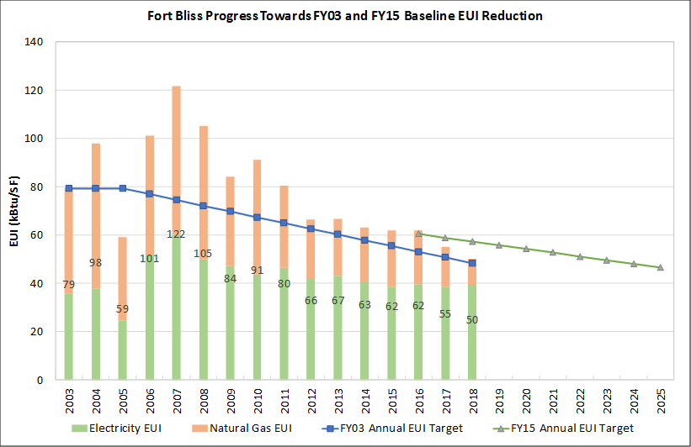
Figure 1. [Installation Name] Energy Use Intensity Performance
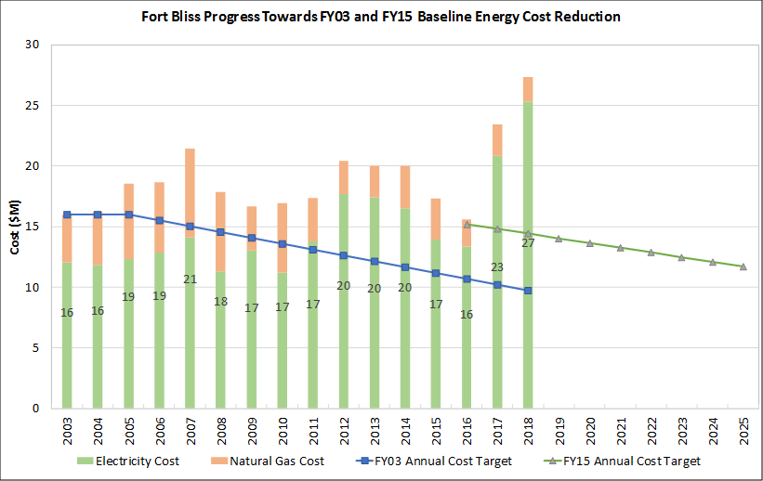
Figure 2. [Installation Name] Energy Utility Costs

Water
Of the total ISR-MC water measures reported in [Insert FY of most recent ISR-MC] [Installation Name] had deficiencies in [Insert number of ISR-MC deficiencies] areas as shown in Table 6.
Table 6. Deficiencies Defined by [Insert FY ISR-MC metrics are from] ISR-MC Water Measures
Water
Attribute | Measure # | Measure | [Insert FY] Response
Assured Access
Infrastructure Condition
System Operation
Critical Mission Sustainment |  |  | Red  Black
The water resilience posture at [Installation Name] is also measured by the operational efficiency with which water is used. Past executive orders have specified potable and non-potable water use intensity (WUI) reduction targets (measured in thousands of gallons [kgal] per square foot of building area). While the current executive order does not specify annual targets, [Installation Name] continues to strive toward these aggressive goals to improve its operational and resource efficiency. Figure 3 and Figure 4 show progress toward reduction targets of [#]% per year from FY[year range]; WUI targets are exceeded but costs have increased, representing a risk.
[Template Note: The information in Figures 3 and 4 is provided as an example. Similar information for each installation can be determined from historical AEWRS data.]
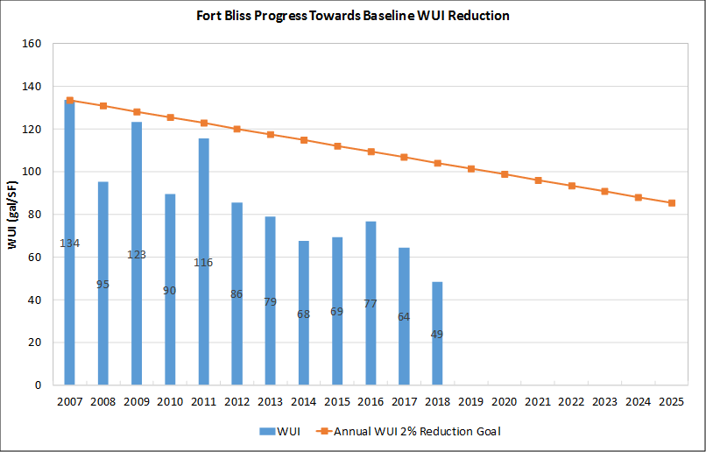
Figure 3. [Installation Name] Water Use Intensity Performance
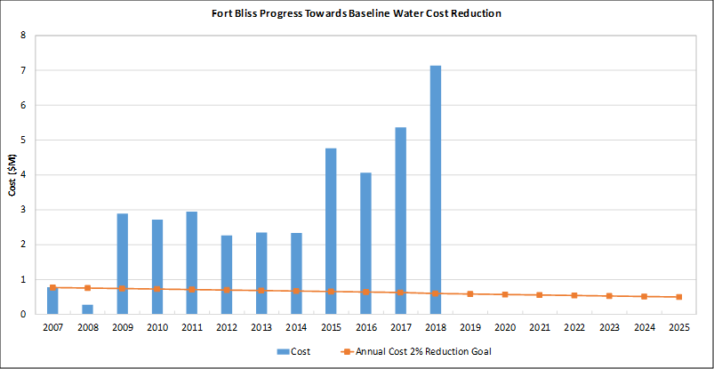
Figure 4. [Installation Name] Water Utility Costs

Implementation Plan
To achieve the E&W security goals outlined in Section 1 and address the specific deficiencies identified in Section 3, an implementation plan has been defined around the following broad strategies:
- Enhance operations and plans (OP) – Actions that reduce overall installation risk from E&W service disruptions through preparedness and improved data quality
- Reduce demand (RD) – Actions that reduce overall installation risk from E&W disruptions and increase the efficiency with which E&W resources are used
- Improve infrastructure (INF) – Actions that reduce risk of disruption at critical facilities through improvements to reliability, redundancy, and exposure
- Increase capacity (CAP) – Actions that enable longer-term sustainment of critical facilities and that reduce risk of disruption at all critical facilities through onsite generation and/or increased supply of E&W utilities
Specific tasks and subtasks have been defined for each strategy and range from low/no-cost to capital-intensive activities. These tasks have been prioritized for implementation based on their contribution to risk reduction, demand reduction, operational efficiency, and specific criteria of importance to installation leadership (e.g., ability to leverage utilities privatization [UP] contracts), as outlined in Section 1. Details of this prioritization and planning effort, including 1) level of impact of each COA to various scoring factors based on installation goals, 2) COA priority rankings, and 3) potential funding and execution mechanisms for each COA are summarized in Appendix E.
Table 7 presents the full list of tasks, accountable parties, potential funding types, and a timeline for implementation over the next 5 years. The tasks address the highest priority deficiencies for the installation and relate to specific COAs considered during the analysis. Many of these tasks relate to specific courses of action considered during the analysis. Appendix D provides project descriptions, identifies the deficiencies addressed, offers funding and execution options, and lists next steps for project implementation for the COAs considered for [Installation Name].
Within this report, COAs are categorized by the four strategies listed above (i.e., OP, RD, INF, and CAP) as well as by utility: electricity (E), natural gas (N), and water (W). These symbols with their corresponding numbers referenced in the table below (e.g., OP-1, CAP-E-1) help direct the reader to the corresponding COA described in more detail in Appendix D. For example, CAP-E-1 refers to the strategy of increase capacity for energy measure #1.

Table 7. [Installation Name] Energy & Water Security Implementation Plan
Task # | Task Title | Responsible Party | Funding Type | Task Start: Year | Task Start: Qtr | Task End: Year | Task End: Qtr
1 | Enhance Operations and Plans
1.1 | Establish Generator Refueling Plans | DPW-Electric | O&M Budget | 2019 | 2 | 2020 | 4
1.1.1 | Update and maintain generator list (OP-1)
1.2 | Ensure Cyber Security of Utility Control Systems
1.2.1 | Review existing UP contracts for cyber security provisions
2 | Improve Infrastructure Condition
2.1 | Improve Electric System Infrastructure |  |  |  | 3
2.1.1 | Repair and replace feeders per capital improvement plan |  | UP Contract |  | 4
2.2 | Improve Water System Infrastructure
2.2.1 | Complete well repairs identified in 5-year capital improvement plan
3 | Increase Capacity
3.1 | Investigate Utility Scale EPE Asset (CAP-E-1)
3.1.1 | Initiate discussions with EPE on costs and benefits of such an asset
4 | Reduce Demand
4.1 | Meter Critical Facilities
4.1.1 | Compare FBWSC’s proposal for water meters to the list of critical facilities and prioritize
4.2 | Install and Optimize Building Controls
4.2.1 | Verify all buildings connected to the enterprise BAS system are on UMCS list

Tracking Progress
The DPW will maintain overall responsibility for the Implementation Plan and tracking progress. Existing planning and performance review forums will be leveraged when possible to facilitate reviews and revisions to this plan. Several aspects of this IEWP will be reviewed and updated annually with different stakeholders, including the following:
- Overall implementation plan progress will be reviewed with the Garrison Commander.
- Planned changes in land uses or buildings that could impact E&W demands will be reviewed with master planning.
- Critical facility lists as well as planned changes in the location of critical mission operations will be reviewed with the Institutional Review Board (see Appendix B). The critical facilities list requires the Senior Commander approval.
- ISR-MC ratings for the current fiscal year will be reviewed for ongoing deficiencies and updated in the appendix.
The comprehensive review of site conditions and the plan shall be conducted at least every 5 years. It is recommended that updates to this plan consider other courses of action identified but not prioritized in this initial implementation plan.
The Excel-based Task Management Tracker, provided as part of the IEWP Template tools, will be maintained by the DPW and used to facilitate tracking progress toward the implementation plan as outlined in Section 4.0.

References
26 U.S.C. § 168. 2018. Title 26. “Income Taxes: Accelerated Cost Recovery System.” Internal Revenue Code, U.S. Internal Revenue Service.
DSIRE – Database of State Incentives for Renewables & Efficiency. 2018. “Modified Accelerated Cost-Recovery System (MACRS).” Last updated August, 21, 2018. http://programs.dsireusa.org/system/program/detail/676
National Institute of Standards and Technology (NIST). 2018. Framework for Improving Critical Infrastructure Cybersecurity, Version 1.1. NIST, Gaithersburg, Maryland. https://www.nist.gov/publications/framework-improving-critical-infrastructure-cybersecurity-version-11
National Renewable Energy Laboratory (NREL). 2018. Federal Tax Incentives for Energy Storage Systems. NREL/FS-7A40-70384. https://www.nrel.gov/docs/fy18osti/70384.pdf
Public Law 115–97. December 22, 2017. Individual Tax Reform and Alternative Minimum Tax. 115th Congress. Accessed September 23, 2018. https://www.congress.gov/115/plaws/publ97/PLAW-115publ97.pdf
Solana AE, WM Warwick, AC Orrell, BJ Russo, KR Parker, MR Weimar, JA Horner, and A Manning. 2011. Renewable Energy Opportunities at Fort Hood, Texas. PNNL-20928, Pacific Northwest National Laboratory, Richland, WA.
U.S. Department of Defense (DoD), Secretary of the Army. February 23, 2017. Memorandum for See Distribution: Army Directive 2017-07. (Installation Energy and Water Security Policy.) https://www.asaie.army.mil/Public/ES/doc/Army_Directive_2017-07.pdf
U.S. Department of Energy (DOE). December 2016. Smart Grid Investment Grant (SGIG) Program Final Report. DOE, Office of Electricity Delivery & Energy Reliability, Washington, D.C. https://www.smartgrid.gov/document/us_doe_office_electricity_delivery_and_energy_reliability_sgig_final_report.html
U.S. Environmental Protection Agency (EPA). 2012. “Data Trends. Water Use Tracking.” Energy Star Portfolio Manager. Available at https://www.energystar.gov/sites/default/files/buildings/tools/DataTrends_Water_20121002.pdf.

–
Planning Process
This appendix provides a detailed description of the planning process that resulted in the [Installation Name] Installation Energy and Water Plan (IEWP). The IEWP provides a roadmap for supporting increased security, resilience, readiness, and mission assurance. It is driven by Army energy and water (E&W) security goals outlined in Army Directive 2017-07, Installation Energy and Water Security Policy, and other federal, Department of Defense (DoD), and Army policies and regulations. The [Installation Name] IEWP is a standalone document for E&W planning but is designed to be coordinated with the installation’s master plan as well as resource management plans and emergency response plans. Its purpose is to address requirements for E&W security and resilience, including energy and water-use efficiency. The [Installation Name] IEWP also meets the following DoD requirements:
- Installation Energy Plan outlined in the Office of the Assistant Secretary of Defense Energy, Installations, and Environment 31 March 2016 Memorandum
- Energy Security Plan outlined in DoD Instruction 4170.11, Installation Energy Management, dated 2016
- Energy and Water Security Plan outlined in the Defense Energy Program Policy Memorandum 92-1, dated 1992
The key elements of the [Installation Name] IEWP planning process are depicted in Figure A.1 in accordance with the Guidance for Installation Energy and Water Plans Memorandum issued by the Army Assistant Chief of Staff for Installation Management (ACSIM) 26 July 2018. Steps 1–4 were performed as part of the current effort and resulting IEWP. The risk assessment portion of the process followed the October 2018 draft Energy and Water Security Guide, developed by the office of the Assistant Secretary of the Army for Installations, Energy and Environmental (ASA IE&E) as a supplement to the IEWP guidance to standardized risk assessment procedures across the Army. Step 5 represents ongoing updates to the plan as [Installation Name] moves forward with implementation.
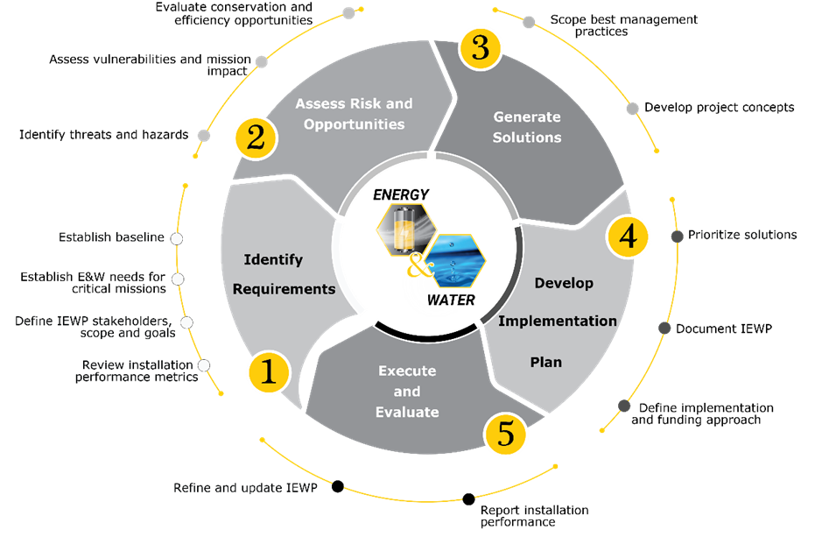
Figure A.1. IEWP Development Process

Identify Requirements
The first step of the [Installation Name] IEWP process was to identify E&W requirements and document the installation’s current baseline. The assessment team performed the steps described in the following subsections.

Identify Stakeholders and Outline Work Plan
[Revise this paragraph as needed per your site-specific approach.] An IEWP kickoff discussion was held with Directorate of Public Works (DPW) personnel on [Insert date]. In this meeting, the assessment team outlined the purpose of the assessment, including how it supports the IEWP, and the approach to conducting the assessment. The team reviewed information needed to prepare for the stakeholder workshop and onsite assessment. A timeline and work plan for executing the assessment was agreed upon. This included establishing weekly status meetings with the Energy Manager at [Installation Name]. The team began working with DPW to identify a list of key stakeholders from within and outside the installation community to engage. Key among these stakeholders are mission owners who will help establish mission needs for E&W resources and the criticality of supporting facilities and infrastructure. Table A.1 contains all stakeholders identified during the IEWP process.
Table A.1. [Installation Name] Stakeholders
Name | Organization/Title | Contact Email | Contact Phone

Gather Existing Data
[Revise these paragraphs as needed per your site-specific approach.] The assessment team submitted a data call spreadsheet to the DPW personnel to gather and forward (electronically) existing data on installation missions, facilities, infrastructure, and utility use. The team reviewed this spreadsheet with the Energy Manager during weekly status calls as data were received.
The data call spreadsheet submitted also included requests for existing data on the installation’s IT/OT infrastructure, policies, plans and previous assessments. Additionally, the questionnaire was used to determine the status of the installation’s risk management framework (RMF) security controls.

Establish Preliminary Energy and Water Security Baseline
The assessment team reviewed the data provided by [Installation Name] and the most recent ISR-MC measures to establish the installation’s current E&W security posture. ISR-MC measures scored as black, red, and amber—as well as any measures with incomplete responses—were used as the preliminary E&W security baseline. The intent of this data review was to establish the E&W security attributes that required onsite investigation.

Identify Critical Missions and Establish Preliminary Assessment Scope
Using the information provided (electronically), the assessment team began assembling a list of critical facilities to be used as a starting point for the [Installation Name] critical mission list and the extent of the assessment. The preliminary list of real property facilities and backup generators was used to create a map, which was also used in stakeholder engagement. Critical mission areas are mapped to facilities and infrastructure. For this mapping, key facility definitions are as follows:
- Critical – A facility that is directly tied to a critical mission and requires energy and/or water to support that mission.
- Non-critical – A facility that is important to overall installation operations, but utility interruption would not have a significant impact on critical missions.

Conduct Stakeholder Engagement
The Stakeholder Engagement Workshop was held at [Installation Name] on [Insert date]. Through this workshop, the assessment team worked to 1) secure the participation of stakeholders in the E&W security planning process, 2) refine and validate the facilities to assess, and 3) establish any installation-specific E&W planning goals. Table A.2 lists the stakeholders who participated in the Stakeholder Engagement Workshop.
Table A.2. Engagement Workshop Stakeholder Participants
Name | Organization | Title

Identify Demand-Reduction Audit Priorities
While onsite for stakeholder engagement, the assessment team met individually with DPW representatives to obtain information on facility E&W use, in order to prepare a list of buildings for demand reduction analysis. The collected information, including proposed conservation or efficiency efforts, was used to identify facilities with either 1) poor E&W efficiency performance or 2) no recent assessment for demand-reduction opportunities. In addition to the interviews, buildings with demand reduction opportunity potential were identified by reviewing the following: 1) installation-level utility use data and Annual Energy and Water Reporting System reporting; 2) building-level E&W use data; 3) real property data; 4) past E&W demand-reduction assessments; 5) energy savings performance contract (ESPC) project lists; and 6) master plans for E&W projects, building demolitions, and major construction efforts.

Define Assessment Goals
The stakeholder engagement was used to define installation-specific goals for the IEWP. Army defined goals are shown in Table A.3. Installation goals, which were approved by the Garrison Commander, are shown in Table A.4. These goals were established early in the planning process to guide the assessment activities as well as for prioritizing solutions and final IEWP drafting purposes.
Table A.3. Army-defined IEWP Goals
 | Critical Mission Sustainment | Critical Mission Risk Reduction | Installation Risk Reduction
Goals | Ensure critical missions have the E&W needed to sustain operations under any operating conditions | Reduce risk of critical mission disruption from E&W system deficiencies | Reduce risk to all installation missions from E&W disruptions and improve performance where life-cycle cost-effective
Table A.4. [Installation Name]-defined IEWP Goals
Goal # | Approved Goals
[Installation Name] Garrison Command presented their definition of a “critical mission” as [insert criteria used to determine critical missions].

Prepare for Onsite Data Collection
Once the footprint of the assessment and goals were established, the team completed preliminary analysis and assembly of key pieces of data in preparation for the onsite data collection. This included identifying gaps in data gathered and reviewing available utility system maps or diagrams to identify infrastructure that supports critical facilities. Interviews were scheduled with mission owners, and an overview of questions to be asked was provided. Interviews were also scheduled with [Relevant additional interviews listed by department]. To facilitate these interviews, the team sent the most recent ISR-MC measure scores (as updated by the assessment team). The team used feedback from the stakeholder engagement to refine the preliminary critical mission facility list.
In preparation for onsite data collection, the team also analyzed facility-level E&W use and intensity to help prioritize onsite facility audits. For facilities that are not metered, the team determined alternative methods for establishing facility E&W demand and data that may have to be collected onsite. The team worked to establish facilities with remotely or centrally accessible building control system data and worked with DPW representatives to obtain and review this data prior to the onsite assessment. This helped to establish potential operational issues and prioritize facilities for demand-reduction assessment, including building-level control system review.

Conduct Onsite Data Collection and Mission-Owner Interviews
The assessment team conducted onsite data collection and mission owner interviews from [Insert date range]. Additional interviews were subsequently completed via teleconference for those mission owners that were not available during the onsite visit. Data were collected to further document the baseline conditions, document system and operational deficiencies, identify demand reduction opportunities, and collect inputs for the risk assessments. See Table A.1 for personnel that were interview.

Collect Data to Refine Critical Facility Lists
Mission owners were interviewed to validate and refine critical facilities and infrastructure. Interview questions were posed to the mission owners to document functions that facilities perform in support of their mission and the ability to reconstitute the mission in the event of energy or water disruption. This information is necessary to clarify mission tolerance for disruption and for establishing baseline operating conditions (to establish a typical operational tempo). The interview data were used to determine how long existing critical mission sustainment (CMS) solutions can keep the facility operational. Facility or infrastructure was designated as critical if 1) it is a defense critical asset or task critical asset, or 2) there is immediate degradation to mission during energy/water outage when existing mitigation solutions do not perform as expected.
The final step was to down-select from the initial list of critical facilities for scoping the assessment itself. The team worked with the DPW representatives to remove certain types of facilities from the list used for the assessment. A total of [#] facilities comprise the critical mission list at [Installation Name]. To focus the assessment, [#] of these critical facilities were targeted for detailed facility-level reviews for deficiencies during the development of this initial IEWP. This included those most dependent on E&W resources (the biggest users) and excluded some redundant facility types (e.g., dining facilities, access control points) with relatively consistent and predictable E&W demands and use patterns. Furthermore, these functions can be easily moved. The Garrison Commander (GC) was provided with this list and approved it on [Insert date]. The GC requested Senior Mission Commander approval, which is pending as of [Insert date, and revise this sentence as appropriate].

Collect Data for Estimating Demand
During the onsite data collection, the team gathered data to support estimation of the E&W needed to sustain facilities and infrastructure for [CMS duration] days. Building-level interval meter data were collected; however, for many facilities this information was not available; therefore, building information such as construction type and age was gathered to assist in the application of estimation tools. The team collected information on the energy, water, and fuel available onsite to support continuous operations at critical facilities. Only onsite supplies, such as onsite renewable energy generation, backup generators, water wells, water reuse, and water storage, were considered.

Collect Data for Risk Assessment
Data collection for the risk assessment focused on understanding conditions and deficiencies that may cause E&W disruptions and the installation’s current risk mitigation approaches. This data collection involves refining the critical facilities lists and establishing baseline conditions for these facilities in terms of assured access (AA), infrastructure condition (IC), and system operation (SO). Data were collected to understand the relative sensitivity of critical mission facilities and infrastructure to E&W disruption, and to understand the associated gaps and deficiencies that would increase the likelihood of any E&W disruption occurring. The risk assessment framework leverages the critical facility list in three key areas:
- Critical mission sustainment (CMS) – Establish whether facilities with little or no tolerance for energy and/or water disruption have the E&W needed to sustain operations for [CMS duration] under all operating conditions. The inability of critical facilities to meet this requirement is considered a deficiency.
- Critical mission risk reduction (CMRR) – Identify deficiencies related to infrastructure condition, lack of redundancy, and infrastructure exposure specifically in, or directly connected to, critical facilities.
- Installation risk reduction (IRR) – Establish general risk to the installation from inadequate operational procedures and plans, overall E&W infrastructure condition, and availability/access to E&W resources to support installation-wide needs. The installation risk assessment used Installation Status Report–Mission Capacity (ISR-MC) ratings as a proxy. It also identified inefficient use of E&W resources in all installation facilities as deficiencies.
The assessment team investigated the current E&W security posture primarily through interviews with DPW personnel and gathering supporting documentation during those discussions. Some inspections of physical conditions were conducted. Onsite data collection for installation risk reduction (IRR) validated baseline conditions related to AA, IC, and SO for installation-level measures and established root causes for E&W security gaps.
Specifically, the interviews collected data about the following:
- Mission-to-mission and mission-to-facility dependencies
- E&W supply, sources, and delivery infrastructure to the critical facility
- Backup E&W resources and procedures to prevent or mitigate disruptions
- Condition of the facility and supporting infrastructure as well as known gaps and deficiencies (i.e., lack of redundancy in the utility systems supporting the facility)
- Time to mission degradation from E&W disruptions assuming no E&W security measures have been implemented
- Time to mission degradation from E&W disruptions assuming current mitigation measures work as intended.
The assessment team collected data on possible E&W demand-reduction opportunities through facility audits. Reducing the amount of E&W needed can extend the length of time that existing onsite energy, water, and fuel resources can sustain critical facilities during outages, as well as reduce the size and cost of proposed solutions.

Assess Risks and Opportunities
The third step in the [Installation Name] IEWP process was to conduct data analysis. Data analysis was performed to establish baseline conditions and E&W security risks and opportunities. The analysis was performed using data from the initial data call and onsite data collection using three approaches unique to the assessment framework (described above) and summarized in Table A.6.
Table A.6. Data Analysis Approaches for Different E&W Security Goals
 | Critical Mission Sustainment | Critical Mission Risk Reduction | Installation Risk Reduction
Establish baseline | -Estimate E&W needed for critical facilities  -Calculate time each facility can be sustained with existing E&W supplies  -Calculate E&W needed by each facility to meet CMS requirement | -Document facility-level deficiencies (e.g., lack of redundancy, poor condition) for all critical facilities  -Document time to impact each critical facility with current backup and facilities with no backup | -Review root cause of ISR-MC scores and other installation-level E&W security concerns  -Review available meter data and conduct water balance assessment as needed
Assess risk | Calculate the shortfall between E&W resources available and needed | -Calculate Mission Impact Index by facility  -Score and rank facilities based on risk | Establish E&W security risk score by attribute (AA, IC, SO) based on validated performance
Identify opportunities | -Analyze E&W use and resource reduction potential via whole-building modeling  -Assess controls optimization opportunities  -Use life-cycle cost tools to define water measures  -Analyze backup and storage potential  -Assess feasibility of onsite renewable/alternative energy | -Map E&W security deficiencies to potential solutions  -Analyze E&W use and resource reduction potential  -Analyze backup and storage potential  -Assess feasibility of onsite renewable/alternative energy | -Map E&W security deficiencies to potential solutions  -Analyze E&W use and identify resource reduction potential through review of previous assessments

Perform Data Analysis for Critical Mission Sustainment
Data analysis was performed for CMS to establish whether facilities with no tolerance for E&W disruption (those on the critical list) have the E&W needed to sustain operations under any operating conditions. The outcome of this analysis quantified the shortfall between the E&W needs for CMS and the E&W availability as provided by current solutions aimed at mitigating the impacts of disruptions. Data analysis for CMS involved the following activities:
- Estimating E&W needed for critical facilities and infrastructure
- Calculating how long each facility can be sustained with existing supplies of electricity, natural gas, water, and fuel
- Calculating E&W needed by each facility to meet CMS requirement ([CMS duration])
- Calculating the CMS shortfall
- Analyzing opportunities to address the gap through the following:
- Energy load/use analysis and reduction potential via building meters, when available, and whole-building modeling and building controls optimization
- Water conservation assessment tools
- Onsite backup and storage sizing and capacity analysis
- Onsite renewable energy/alternative water-production feasibility tools
- Calculating contribution of solutions toward CMS requirement
- Estimating costs/benefits.
Risk is associated with the CMS shortfall, which is measured by ISR-MC scores. The measure scores for this attribute were used to assess current risk associated with failing to meet the CMS requirement. The assessment team recommended revisions to CMS scores for the installation based on the baseline assessment results. Remaining black, red, and amber scores represent unacceptable risk that must be mitigated. The team analyzed the baseline data to document the root cause of CMS shortfalls. The assessment team then identified opportunities to close gaps and bring the critical missions closer to meeting the CMS requirement as described in the bullets above.

Perform Data Analysis for Critical Mission Risk Reduction
Data analysis was performed for critical mission risk reduction (CMRR) to assess risk associated with all facilities and infrastructure on the critical mission list. Risk is based on the presence of deficiencies in the supporting utility systems and the mission sensitivity to E&W disruptions. A deficiency is a flaw affecting the integrity of an infrastructure that, when compromised, causes the degradation or failure of a critical mission.
The assessment team applied a scoring method to identify critical missions vulnerable to E&W disruption and prioritize solutions to reduce this risk. The Mission Impact Index scores facilities using a qualitative scale adapted from standard risk assessment approaches in critical infrastructure risk management. Figure A.2 depicts factors included in the Mission Impact Index. The results of this analysis were classified secret. (See explanation in Section A.3.)
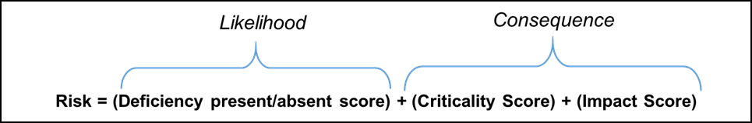
Figure A.2. E&W Security Mission Impact Index
The assessment team used interview data and infrastructure information to identify E&W security deficiencies at [Installation Name] and apply these to the calculation of the Mission Impact Index for all critical facilities. The highest-scoring facilities and infrastructure represent the greatest risk and became the focus of solution development.
The Mission Impact Index is determined by both the likelihood of an event that would cause energy or water disruption and the consequence of such a disruption to the mission. Likelihood is based solely on the absence or presence of deficiencies. If one or more deficiency is associated with the facility and its supporting infrastructure, it is more likely to experience an E&W outage and, therefore, will receive a higher index score. Consequence reflects the sensitivity of a mission to E&W disruptions that might arise from identified deficiencies.
Table A.7 describes the steps taken by the team for analysis of the likelihood factor (scored by the presence or absence of a deficiency). The assessment team documented the presence of E&W security deficiencies for each critical facility. These deficiencies are captured by three general factors—redundancy, system design, and system condition—with associated scoring that is relevant to each utility (electricity, natural gas, and water/wastewater). Table A.7 gives the scoring factors for electricity as a representative example.
Table A.7. Likelihood Calculation Steps
Deficiency Factors: Electrical
System Redundancy Risk Factors  Criteria  (A) Non-co-located redundant feeds serving the installation or system  (B) Non-co-located redundant feeders serving the facility  (C) Redundant substations or redundant substation transformers serving the facility  Possible Score  4 = No to all  3 = Yes to one OR Unknown  2 = Yes to two risk criteria above or unknown  1 = Yes to all risk criteria above  0 = N/A – Facility does not use electricity | System Design  Criteria  (A) Does the location of electrical distribution lines serving the facility create exposure to likely hazards/threats to the site (e.g., lines aboveground in tornado-prone areas, lines underground in flood-prone areas)?  (B) Does the location and design of the substation serving the facility create exposure to likely hazards/threats to the site (e.g., outside the fence line, no lighting arrestors)?  (C) Do substation or distribution circuits servings the facility require manual switching to reroute power in a disruption (i.e., no automated switching capability)?  Possible Score  4 = Yes to all  3 = Yes to two OR Unknown  2 = Yes to one  1 = No to all  0 = N/A – Facility does not use electricity | System Condition  Criteria  Is any electrical system infrastructure (i.e., lines, transformers, substations, etc.) serving the facility in poor condition?  Possible Score  3 = Yes  2 = Unknown  1 = No  0 = N/A – Facility does not use electricity
Table A.8 describes the steps for analysis of the consequence factor (impact to mission). The Consequence factor reflects the sensitivity of a mission to E&W disruptions that might arise from identified deficiencies. The consequence factor is scored based on two variables: impact and criticality. The impact factor considers how quickly the impact would occur and how prepared the facility is to respond to interruption considering current measures in place. The criticality variable considers the number of missions impacted; more missions supported by the given facility or infrastructure means higher risk if that facility or infrastructure fails. The criticality variable also assigns extra weight to prioritized critical facilities. The larger the final number, the greater the risk associated with that facility. This scoring process was completed for each major utility at [Installation Name]—electricity, natural gas, and water/wastewater [Revise utility list for specific site].
Table A.8. Consequence Calculation Steps
Criticality Factors
Facility Criticality (as designated by garrison)  Possible Scores  4 = Operational and Infrastructure  3 = Army Mission  2 = DoD/Federal/Other  1 = Personnel Affected | Number of Missions Supported  Possible Score  3 = Supports all missions  2 = Supports more than one mission  1 = Supports one mission
Impact Factors
Hours to Mission Degradation if Existing Onsite Electrical Backup Sources Perform as Expected  Possible Scores  6 = Immediate (0–0.5)  5 = 0.5–5 Hours  4 = >5–8 Hours  3 = >8–16 Hours  2 = >16–48 Hours  1 = >48–336 Hours  0 = 336+ Hours | Hours to Mission Degradation if Onsite Electrical Backup Sources Fail to Perform  Possible Scores  6 = Immediate (0–0.5)  5 = 0–5 hours  4 = >5–8 hours  3 = >8–16 hours  2 = >16–48 hours  1 = >48–336 hours  0 = 336+ hours
Facility Backup Factors
Criteria  (A) Does a backup power system (e.g., generator, microgrid) serve the facility?  (B) Is the backup power system designed/sized to meet the critical electrical demand of the facility?  (C) Is the backup power system designed to withstand the most likely hazards/threats to the site (e.g., generator on raised platform or roof in flood-prone areas)?  (D) Is the backup power system serving the facility in good condition, well-maintained (with documented maintenance logs) and tested to ensure reliability? | Facility Backup  Possible Scores  5 = No to A  4 = No to B, C, and D  3 = No to two of B, C, or D  2 = No to one of B, C, or D  1 = Yes to all  0 = N/A – Facility does not use electricity
After completing the Mission Impact Index for each facility, the results were used to help focus the identification of solutions for CMRR.

Perform Data Analysis for Installation Risk Reduction
A root cause analysis was performed for those ISR-MC scores that remained black, red, or amber after the baseline data was collected and validated. This data analysis is necessary for identifying solutions to reduce risk at the installation-level.

Generate Solutions
The assessment team generated viable solutions to reduce the risk associated with identified gaps and deficiencies as a result of understanding the installation mission priorities, current installation infrastructure condition, root causes of Installation Status Report-Mission Capacity (ISR-MC) scores, required and planned infrastructure upgrades, fuel storage and backup power at each facility, current emergency response planning, power storage technologies, and alternative water sources (among other factors). Solutions were also generated to leverage demand-reduction opportunities and improve installation E&W performance.

Develop Risk Reduction Solutions
In order to reduce E&W security risks, the assessment team generated solutions by targeting E&W security deficiencies in each area, critical mission sustainment (CMS), critical mission risk reduction (CMRR), and installation risk reduction (IRR). Solutions for CMS began through analysis of backup and storage sizing and capacity for E&W. The team evaluated onsite renewable energy and alternative energy/water feasibility and analyzed energy loads/use and resource reduction potential via whole-building modeling. Solutions for CMRR focused on closing identified deficiencies and gaps at the highest scoring facilities from the Mission Impact Index calculations. The team leveraged ISR-MC scores to understand IRR and to identify potential projects and Best Management Practices to reduce overall risk and improve operational efficiency.

Identify Demand-Reduction Opportunities
The assessment team compiled available data sets to develop facility baseline conditions, including operations, utility consumption, and utility costs. As part of the facility baseline development, [edit as needed for specific installation] several distinct analyses were performed during the 2018 SRA and leveraged for the IEWP, including the following:
- Analysis of meter data and/or billing data to understand baseline conditions. Available monthly meter data were provided by Directorate of Public Works (DPW).
- Whole-building modeling based on data collected during building walkthroughs to establish baseline consumption patterns to substitute for building-level interval and monthly meter data.
- Extrapolation and estimation based on similar buildings or building functions to estimate E&W demand and consumption where no other data were available.
Once the building baselines were developed, energy demand-reduction opportunities were identified through an analysis of energy savings and cost savings. Onsite interviews with DPW and mission owners helped to inform this broader analysis, which, like the development of facility baseline consumption patterns, involved several distinct analyses, including the following:
- An analysis of utility rates to obtain the marginal cost of electricity, electric demand, natural gas, water and wastewater for use in assessing cost savings in building modeling and retrofit analysis.
- The use of Facility Energy Decision System (FEDS) building energy models to evaluate the impact of potential E&W demand-reduction solutions in terms of energy and cost reduction; modeling included details such as building age; use-type; occupancy patterns; geometry; envelope; heating, ventilation and air conditioning (HVAC) and controls; lighting; DHW; plug loads; and motors.
Just as the baseline consumption information was extrapolated to buildings without data, opportunities were also extrapolated to non-modeled buildings, as described in the COAs in Appendix D.

Information Classification
This section outlines the treatment of sensitive information in support of the [Installation Name] IEWP. Neither the assessment team nor the security points of contact at [Installation Name] have Original Classification Authority (OCA) to assign security classification to the data collected or analysis performed. This section provides a written explanation of how the information was treated in the assessment and development of the IEWP. This includes a review of relevant classification guides and regulations, a summary of the data collected for [Installation Name], and the associated treatment of information.

Relevant Security Classification Guides and Regulations
Two security classification guides (SCGs) were found to cover energy/water security topics or mission asset/infrastructure information in the Defense Technical Information Center (DTIC) SCG database (UNCLASSIFIED) or in coordination with DoD, Army G-2, G-3/5/7, or Office of the Assistant Chief of Staff for Installation Management. Relevant excerpts from these documents are summarized below.

The Defense Critical Infrastructure (DCI) Line of Effort (LOE) SCG, issued 27 July 2018
The DCI-LOE-SCG replaces DoDM 3020.45-M V3 (May 2013), and is the primary classification guide referenced for the Energy and Water Security Assessment and IEWP work. This guide specifically pertains to the classification of baseline elements of information (BEIs) relating to DCI assets when associated with the terms and acronyms “Task Critical Asset (TCA)” or “Defense Critical Asset (DCA).” As detailed in the Office of the Secretary of Defense Memo (July 2018), Interim Baseline Elements of Information for Mission Assurance, BEIs include characteristics such as asset name, asset location, functional status, mission type, mission impact, criticality, threats, hazards, vulnerabilities, and other related types of information.
While a compilation of unclassified information is normally not classified, the DCI notes that in certain circumstances information that would otherwise be marked unclassified may become classified when combined with other unclassified information. Should the compiled information reveal an additional association or relationship that meets the standards for classification in the DCI SCG, and that is not otherwise revealed in the individual items of information, then it may be classified because of the association revealed. Relevant sections of the DCI general classification guidance are provided in the Table A.9.
Table A.9. Sections from Defense Critical Infrastructure Guidance Applicable to [Installation Name] IEWP
Section | Topic | Class
1.5 | The concept that DoD operations depend on specific assets/capabilities and infrastructure; or that disruption of any asset/capability or infrastructure may adversely affect DoD operations. | U
1.6 | - The fact that DoD analyzes/assesses the criticality and vulnerability of its assets and infrastructure; or  - DoD’s dependence on commercial assets or in infrastructure; or  - The fact that DoD takes actions to remediate or mitigate its vulnerabilities and to assure its military operations and that it monitors and reports the status of assets and infrastructure supporting operations and activities | U
1.8 | Association of assets with specific Mission Essential Tasks or operational capabilities. If the asset or the impact of loss of the asset, when associated with a plan or operation is at a higher classification level, then this information is classified, at a minimum, at the classification level of the asset identified, or as is required for the plan or operation. | U – TS (based on mission requirement)
For classes, U = unclassified, TS = top secret

Army Regulation 380-5, Department of the Army Information Security Program
Army Regulation (AR) 380-5, Department of the Army Information Security Program, implements Executive Order (EO) 12958 (now EO 13526 Section – Dec 2009) and DoD Regulation 5200.1–R. AR 380-5 contains the minimum Department of the Army standards for the protection of classified information and material. Original classification is the decision to designate a certain item of information as classified, at a particular level and for a certain duration of time. These decisions can only be made by persons designated in writing by either the Secretary of the Army or the Army Deputy Chief of Staff for Intelligence, as OCA.
Derivative classification is the incorporating, restating, paraphrasing, or generating in new form information that has already been determined to be classified, and ensuring that it is classified and handled at the level determined by the OCA. Derivative classification can be accomplished by any properly cleared personnel. Generally, a compilation of unclassified items of information is not classified. In unusual circumstances, compilation of items of information that is individually unclassified can be classified if the compiled information reveals an additional association or relationship that matches criteria for classification as described in Section 1.4 of EO 13256. Section 1.5 (g) of EO 12958 notes “Vulnerabilities or capabilities of systems, installations, infrastructures, projects or plans relating to the national security” may be classified. Classification by compilation will be fully supported by a written explanation that will be provided on, in, or with the material containing the information. An OCA must be consulted if guidance is required concerning whether the compilation results in classification. Current Headquarters, Department of the Army (HQDA) OCAs for Energy and Water Security Assessments and IEWPs are Mr. Jordan Gillis, Acting ASA (IE&E), and LTG Gwen Bingham ACSIM.

Treatment of Information in the Energy and Water Security Assessment for [Installation Name]
All recommended decisions outlined in this section have been made as derivative classification by both a DOE [Specific national laboratory or responsible contractor]-approved derivative classifier and HQDA technical monitor with appropriate clearance levels. The following information generated as part of the [Installation Name] assessment and IEWP will be treated as classified based on the best available information and technical judgement of the technical team:
- All information associated with terms “TCA” is treated as classified (S) in accordance with DCI LOE SCG (27 July 2018), Section 1.8. This material will be provided to [Installation Name] by SIPRNet as “Appendix F, CLASSIFIED Findings.”
- Detailed risk assessment (mission impact index – see Figure A.2), associated with the mission critical facilities only, are treated as classified (S). It is the technical team’s interpretation that the aggregation of the unclassified data listed below has the potential to create a higher classification level, in accordance with AR 380-5 and EO 12958 Section 1.5 (fg). The technical team is treating the material as classified (S) until an appropriate Army OCA can review and provide additional guidance. This material will be provided to [Installation Name] by SIPRNet as “Appendix F, CLASSIFIED Findings.”
- Specific missions
- Associated, specific facilities
- Baseline and/or gaps E&W security
- Likelihood of E&W disruptions
- Time to mission degradation from E&W disruptions
- Mission Impact Index scores by facility.
All other data generated by the assessment in support of the IEWP for [Installation Name] are being treated as Unclassified / For Official Use Only in accordance with AR 380-5 and DCI LOE SCG guidance that states generally, a compilation of unclassified items of information is not classified. This includes but is not limited to the following:
- Facilities associated with specific, unclassified mission requirements
- Baseline and/or gaps E&W security associated with specific infrastructure or facilities and unclassified mission requirements
- Time to impact mission of an E&W disruption, if provided unclassified
- Prioritized solutions to address identified gaps.

–
Critical Facilities
A total of [#] facilities comprise the critical facility list at [Installation Name]. A subset of [#] of these facilities were included in the detailed risk assessment. (See Table 1 in the main body of this report.) An installation map showing the location of the critical facilities is in Section B.1. Section B.2 lists the critical facilities, as approved by the Senior Commander, separated by facilities included and excluded from the assessment.

Critical Facilities Approval Memo
[Insert memo signed by the Senior Commander approving the critical facilities list. Below is an example of a signed memo.]
DEPARTMENT OF THE ARMY
[Template Note: Place memo on appropriate garrison letterhead]

Memorandum for CG

SUBJECT: Critical Facilities and Infrastructure List for [Installation Name].

1. Purpose. Request Senior Commander review and concurrence on the enclosed facilities and infrastructure supporting critical missions at [Installation Name] (see Encl). This list will be used as a key input to an assessment and planning to reduce energy and water security and resilience risk at [Installation Name].

2. Background. Army Directive 2017-07 (Installation Energy and Water Security Policy) dated 23 February 2017 requires all senior commanders to “work with mission owners and tenants to assess and prioritize installation-critical energy and water requirements to support the mission of an installation.” Additionally, the ACSIM Guidance for Installation Energy and Water Plans (IEWPs) issued on 26 July 2018 requires the Senior Commander to set the critical requirements and work with the Garrison Commander and Directorate of Public Works to outline the energy and water needs to these critical missions.

3. The [Installation Name] garrison team identified the facilities and infrastructure that support critical missions. This list has been developed through interviews with mission owners and directorate support personnel. The complete list enclosed (Encl) represents the total critical requirement and has intentionally not been prioritized. This list will be a baseline input to an energy and water security and resilience assessment, and any deficiencies in energy and water to the facilities on this list will be prioritized with garrison and command leadership as part of the [Installation Name] IEWP development.

4. IEWP Development. As outlined by the ACSIM Guidance, all Army garrisons are required to have an IEWP as a roadmap to achieve increased security, resilience, readiness, and mission assurance. The IEWP is a stand-alone document for energy and water planning but is designed to be coordinated with the installation master plan, as well as installation-level planning requirements like resource management and emergency response plans. IEWP development will include assessment of any energy and water security risks to facilities and infrastructure supporting critical missions at [Installation Name] as well as opportunities to improve the overall efficiency of energy and water systems to support resilience and conserve financial resources. The final IEWP for [Installation Name] is due by [Insert date].

5. Request Approval. The document enclosed is the draft list of facilities and infrastructure that support critical missions on [Installation Name]. We request your review and concurrence on this list to meet the requirement in Army Directive 2017-07 and as the basis for determining the critical energy and water requirements to be considered in the [Installation Name] IEWP.

6. My point of contract for this memorandum is [Insert name, email address, and phone number]

______________________________________
Senior Commander

Encls

Installation Maps of Critical Facilities
[Revise this paragraph as needed to match your figure legend] The following figures provide installation maps of the critical facilities included in the [year] [Installation Name] assessment.
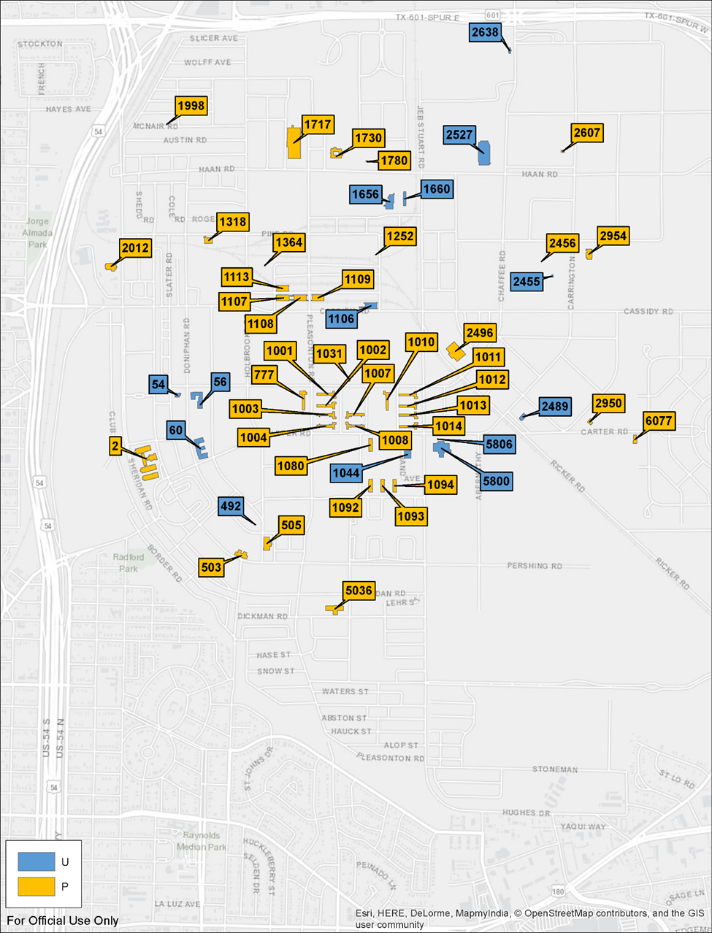
Figure B.1. Critical Facilities: [Specific area name]

Figure B.2. Critical Facilities: [Specific area name]

Approved Critical Mission Facility List
Table B.1 lists the critical facilities included in the [year] [Installation Name] assessment. As noted in Section B.1, these facilities have been approved by the Senior Commander as critical to the mission of [Installation Name].
Table B.1. List of Critical Facilities Included in [Year] Assessment
Critical Facility Priority | Facility # | Facility Description | Mission Owner
Installation-Defined Priority X
Installation-Defined Priority X

–
Baseline Conditions and Risk Assessment
In order to assess the current energy and water (E&W) security posture for [Installation Name], it is important to understand the current conditions at the installation, including E&W supply and distribution, consumption and costs, ongoing and planned E&W projects, and future garrison development. In addition to the current conditions, an understanding of the risks to E&W security for the critical missions is required. This risk assessment includes a discussion of the risk of disruption of utilities ([list utilities available onsite]) to missions, as well as a review of natural hazard information for [Installation Name]. This appendix presents this baseline and risk information to provide foundational elements for the identification and development of courses of action (COAs).

Hazard Assessment
There are several hazards that could potentially impact the [Instillation Name] area. [Include a sentence listing the hazards that could potentially impact the site]. To help improve grid reliability and resilience, major or frequent hazard impacts should be considered when planning and developing infrastructure projects. Table C.1 shows the most common hazard events impacting the [Installation Name] area since [Year]. The number of occurrences was gathered from the National Oceanic and Atmospheric Administration Storm Events Database.
Table C.1. Natural Hazards Impacting the [Installation Name] Area Since [Insert Year]
Category | # of Reported Occurrences
Category | [Location A] | [Location B] | [Location C]
High Winds/Thunderstorms
Hail
Drought
Floods
Winter Weather
Extreme Temperatures
Other Natural Hazards, Etc.
Most of the events impacting [Installation Name] involve [List most prevalent hazards].

High Winds, Thunderstorms, and Hail
Strong winds resulting from severe thunderstorms, tornados, and hurricanes are one of the primary causes of damage to electric networks, especially to distribution systems, and to buildings. Most other infrastructure systems, such as drinking water and natural gas, are not likely to be significantly damaged by strong winds. However, there is a potential for strong winds to damage undergrounded infrastructure. For example, strong winds can topple a tree, causing the tree’s root system to damage buried cables and pipes. [Template Note: Insert information here on hazards of this nature that have occurred on or near the site, and their consequences.]
General measures that can help reduce risk of wind damage to power systems include maintaining good tree trimming policies to reduce the likelihood of trees and branches falling across power lines, burying lines to eliminate exposure to strong winds, and designing systems (e.g., distribution poles) to withstand high wind speeds.

Drought
Drought can be a frequent hazard in areas surrounding [Installation Name]. [Template Note: Insert information here on hazards of this nature that have occurred on or near the site, and their consequences.]
A severe drought can also impact the electric power industry. As surface water availability decreases, some industries such as agriculture may rely more on well water. This increased pumping can increase electric power consumption. A drought causing low water levels can also reduce hydro generation or thermal plant generation because of lack of water.
[Template Note: Insert a paragraph describing efforts that have been taken to reduce the consequences of a drought. These may include building redundancies into water systems, reducing demand for water through conservation, using reclaimed water, or identifying alternative water sources.]

Flooding
Flooding is one of the most prevalent disasters across the United States, and the area near [Installation Name] is not immune from the flood threat. [Template Note: Insert information here on hazards of this nature that have occurred on or near the site, and their consequences.]
Flood waters can cause significant damage to buildings and infrastructure. For example, wastewater treatment plants tend to be located at a low point along a river or major body of water, making them vulnerable to flooding. Communications switches and backup generators can also be at risk, especially if they are in a basement or low-lying area. On the electric power system, flood waters can damage electrical equipment such as meters, disconnect switches, and other components in a substation such as transformers. Surface water for drinking systems can also be at risk because of debris, water quality issues, or damage to water intake equipment following a flood. Flooded roadways can cause ingress and egress problems. This can delay repair and recovery efforts if there are infrastructure outages.
[Template Note: Insert information here on the susceptibility of assets examined during the assessment to flooding.]
[Template Note: Insert a paragraph describing efforts that have been taken to reduce the consequences of a flooding.]

Winter Weather / Extreme Temperatures
[Template Note: Insert information here on the risk of winter weather/extreme temperatures at the site. Include information on winter weather/extreme temperature events that have occurred and the historic impact.]
Events like this deep freeze can result in simultaneous loss of commercial electric power and natural gas services. Onsite storage of compressed natural gas for backup generation may be considered to help reduce the risk of an infrastructure disruption impacting a facility.
[Template Note: Insert a paragraph describing efforts that have been taken to reduce the consequences of a winter weather/extreme temperatures.]

Energy and Water Operations
[Template Note: This is example text. Modify as needed for your installation.]
The DPW team maintains supply, infrastructure, emergency planning, and daily operations of energy and water infrastructure and systems to support mission execution. Within this construct, DPW’s role includes the following:
- Facilitate continued mission owner engagement and utilize regular communication channels to make sure that mission priorities are reflected in DPW planning processes.
- Implement system operations recommendations within DPW teams and make sure that support contracts are developed with these requirements in mind.
- Provide continued input into prioritization of both project concepts and procurement/acquisition strategies [e.g., Energy Savings Performance Contract (ESPC)/Utility Energy Savings Contract (UESC), leases, Energy Resilience and Conservation Investment Program (ERCIP) submissions].
Key DPW POCs are listed in Table C.2.
Table C.2. Department of Public Works (DPW) Points of Contacts
Position / Department | Name
Director, Public Works
Deputy Director, Public Works
Chief of Business Operation and Integration Division
Pollution Prevention Branch Manager
Sustainability Branch Chief
Energy Program Manager
Energy Manager
REM
Chief of Systems Management Branch
Environmental Division (EA/NEPA, water, emissions permits, etc.)
Mechanical Systems Manager
Water Systems Manager
Electrical Systems Manager
Power Pro
O&M - water systems
Steam Plant Manager
Business Ops (utility billing and rates analysis, contracts, etc.)
Electrical Inspector
Master Planning
SCADA
Director of Public Works, YTC
Among the many responsibilities of the [Installation Name] DPW is the management of energy and water provision for installation activities. This includes ensuring the amount of energy or water required is delivered at the time it is required in a safe, cost-effective, and efficient manner. This has many implications, including the focus of this assessment, energy and water security and resilience for critical mission sustainment.
[Template Note: Insert an overview of energy and water installation management details as appropriate.]

Electricity

Infrastructure Overview

Main Cantonment Electricity Supply
[Template Note: This section describes the main part of the onsite electric system. It should include the following:
- Outside utility electricity supplier(s)
- Description of transmission system in the area
- Information about regional electric generation assets
- Number of substations serving the installation, including location and ownership details
- Description of transmission / sub-transmission system on the installation (if applicable)
- Description of the distribution system on the installation. Important items to note include any isolated sections of the distribution system still considered main cantonment, where options for switching one feeder to another may be limited
- Satellite imagery annotated with substation locations and transmission line routes is preferred
- Utility Privatization / ownership information, especially if the privatization was recent
- Include any existing renewable energy sources; note ownership and Power Purchase Agreements (PPAs) or other relevant contractual agreements
- Include any mitigation measures being planned or currently undertaken to address known deficiencies.
- The paragraphs below are included as examples.]

Ranges Electricity Supply
[Template Note: This optional section should be used to describe any outlying sections of electric infrastructure. These will be areas that that either do not support critical facilities or are completely separate from the main cantonment. It should include
- Area location
- What types of facilities / missions are supported
- Substation information
- The power source for the substation
- Any options for backup power from other substations
- Include any existing renewable energy sources. Note ownership and PPAs or other relevant contractual agreements.
- Satellite imagery annotated with substation locations and transmission line routes is preferred.]

Rate Structure
[Template Note: This section should be used to describe the electric rate that the primary utility or utilities have in place for the installation. This information should include rate class, blended rate, rate details (e.g., demand charges, firm/interruptible load), and significant historical or upcoming rate changes. Demand charges and opportunities for rate reduction should be noted, as well as any potential negative impacts to consumption reduction. Specifics of historical usage should be in the next section.]

Demand
[Template Note: Any available historical demand/energy usage data available from utility bills can be presented here. These data should illustrate loading trends as they vary seasonally and daily. If available, critical facility demand should also be reviewed and compared to total installation demand.]

Installation Risk
The Installation Status Report – Mission Capacity (ISR-MC) indicates an installation’s level of risk exposure to an energy or water outage, as well as the capability of an installation to sustain critical mission activities during an outage. The ISR-MC report evaluates progress against four attributes defined in Army Directive 2017-07: Assured Access, Infrastructure Condition, System Operation, and Critical Mission Sustainment. Each attribute has multiple measures that characterize the condition of that attribute. Each measure can be scored as green+ or green (best), amber, red, or black (worst), based on specific criteria established each measure.
[Template Note: Insert full ISR-MC scores for Energy. Provide some discussion of the electric utility ISR-MC scores, discussing strong points and areas for improvement.]
For purposes of this risk assessment, any item characterized by a score of amber, red, or black is considered an installation risk. This list of ISR-MC measures and corresponding scores is used to inform the development of COAs. For each ISR-MC measure that received a score of amber, red, or black, a corresponding COA was developed, which, if implemented, would improve the ISR-MC score and thus reduce installation risk.
The critical mission risk evaluation assessed the risk to critical facilities from deficiencies in the [insert utility] system, to include redundancy, system design, and system condition. The methods for this evaluation are detailed in Appendix A. [Insert utility] deficiencies are presented in detail in Section C.3.6, to include the number of critical facilities that have the potential to be affected by the identified system deficiencies. Specific facilities affected and resulting risk scores are treated as classified information and can be found in Appendix F, CLASSIFIED Findings.
[Template Note: Add additional detail that may help describe risks specific to the utility.]

Critical Mission Sustainment
[Template Note: This section should describe the existing infrastructure and equipment that provides electrical power for critical mission sustainment. In most cases that will default to a discussion of available backup generator resources but should also include any UPS and microgrid systems that exist. The generator information should include the following:
- Sources of data (generator size, fuel, location, tank size)
- Deficiencies in data
- Summary of backup generator coverage of critical facilities
- Analysis of generator age distribution with useful lifespans and any replacement programs noted
- Review of generator brands
- Distribution of fuel types, noting any dual-fuel capabilities.
If available, a summary of forecasted runtimes should be included along with fuel storage information. This will highlight and inform fuel storage deficiencies.
The paragraphs below may be useful as-is but should be reviewed for accuracy and relevancy.]
Consistent with Army Regulation (AR) 420-1, backup power needs for critical missions on [Installation Name] are met primarily with auxiliary generators permanently integrated with the facility’s electrical systems. Across the installation, generators serve critical Army and Department of Defense facilities, privatized infrastructure (water and wastewater), ranges, and tenant missions. Approximately [#] generators were identified as being in service across critical facilities.
Information for the generator analysis was gathered from [Insert sources of generator data] [Describe any gaps in the collected data].
Table C.2 summarizes the coverage of backup generators across the critical facilities. The critical mission sustainment (CMS) requirement focuses on critical facilities. Only [#] of the [#] facilities assessed have generators with adequate fuel storage at the facility to operate for at least [CMS duration] days; another [#] of these generators are configured to run on natural gas and could theoretically sustain critical missions, but do not meet the requirement because fuel is not stored onsite.
Table C.2. Critical Facility Generators
Critical Facility Priority | Total # of Assessed Facilities | # of Assessed Facilities with Confirmed Generator(s) | Notes
Installation-Defined Priority X | [#] | [#] ([#]%)
Installation-Defined Priority X | [#] | [#] ([#]%)

Generator age can be one indicator of performance and reliability. [Template Note: Include a discussion of generator age distribution here along with graphical depictions. The paragraphs that follow are an example and should be revised/replaced with your installation-specific text and figures.]
The useful life on an engine generator will depend in part on the run-hours of operation, maintenance, and upkeep, and availability of replacement parts and consumables (fuel filters, belts, etc.). Army Technical Manual 5-685 indicates that overhaul of the equipment should occur every 10 years or 16,000 hours of auxiliary use, although manufacturer guidelines and installation best practices may reduce these figures.
[Template Note: Provide information on the operating time for generators serving critical facilities before the fuel tank must be refilled. Below is an example of how generator loading estimates may be generated and subsequently used to calculate operating time.]
Generator loading estimates were based on an assumed loading of the generator, with ranges from 30% loading for some large facilities with a limited number of building circuits served by the generator, up to 75% for generators serving facilities with a larger portion of the building loads served by emergency circuits (such as NEC application delivery networks or facilities with data centers). Where interval data was available, it was used to validate generator loading estimates; for facilities without interval data, consumption estimates were produced through energy models, proxy facility load characteristics, and monthly metered data.
Generator efficiency was assumed to be an industry standard 30% for operation of typical smaller units (200 kW and below) and assumed to be higher (35%) for larger equipment. Efficiency was used to calculate the rate of diesel consumption. This was coupled with the known size of the day-tank located with the generator, assuming a reserve margin. Critical facilities with unknown fuel tank sizing were excluded from the calculations.
[Template Note: Include some discussion of fuel storage requirements based on estimated runtime. Contrast the requirement to existing storage capability. Indicate plans to access capitalized reserves, or alternate means of refueling.]

Critical Mission Risk
The CMS evaluation assessed the risk to critical facilities from deficiencies in the electrical system, to include lack of backup power, system exposure, poor infrastructure condition, and lack of redundancy. Electrical deficiencies are presented in detail in Section 3.2.1, to include the number of critical facilities that have the potential to be affected by the identified deficiencies. Specific facilities affected and resulting risk scores are treated as classified information and can be found in Appendix F, CLASSIFIED Findings.

Gas

Infrastructure Overview
[Template Note: This section describes the onsite Gas system. It should include the following:
- Outside utility supplier(s)
- Description of transmission system in the area, including surrounding infrastructure elements and operating/design PSI of the transmission lines
- Information on regional production assets
- Number and location of primary regulator and metering stations
- Description of the distribution system on the installation. Important items to note include any alternate (looped) feed options for contingencies
- Satellite imagery annotated with transmission line routes and metering stations is preferred
- Utility Privatization / ownership information, especially if the privatization was recent
- Include any mitigation measures being planned or currently undertaken to address known deficiencies.]

Rate Structure
[Template Note: This section should be used to describe the natural gas rates in place for the installation. Rates may include wheeling (delivery) and purchase (commodity) rates. This information should include Rate Class and Rate details, and significant historical or upcoming rate changes. ]

Demand
[Template Note: Any available historical demand / energy usage data available from utility bills can be presented here. These data should illustrate loading trends as they vary seasonally and daily. If available, critical facility demand should also be reviewed and compared to total installation demand.]

Installation Risk
As described in Section C.3.4, installation risk was characterized based on ISR-MC scores.
[Template Note: Provide some discussion of the gas utility ISR-MC scores, discussing strong points and areas for improvement.]
For purposes of this risk assessment, any item characterized by a score of amber, red, or black is considered an installation risk. This list of ISR-MC measures and corresponding scores is used to inform the development of COAs. For each ISR-MC measure that received a score of amber, red, or black, a corresponding COA was developed, which, if implemented, would improve the ISR-MC score and thus reduce installation risk.
The critical mission risk evaluation assessed the risk to critical facilities from deficiencies in the [insert utility] system, to include redundancy, system design, and system condition. The methods for this evaluation are detailed in Appendix A. [Insert utility] deficiencies are presented in detail in Section C.4.6, to include the number of critical facilities that have the potential to be affected by the identified system deficiencies. Specific facilities affected and resulting risk scores are treated as classified information and can be found in Appendix F, CLASSIFIED Findings.
[Template Note: Add additional detail that may help describe risks specific to the utility.]

Critical Mission Sustainment
Critical mission facilities at [Installation Name] have limited reliance on natural gas for mission execution. Natural gas is used as a fuel source for [Insert list of natural gas uses onsite].
[Template Note: Provide details as necessary.]

Critical Mission Risk
The critical mission risk evaluation assessed the risk to critical interruptible and priority facilities from deficiencies in the natural gas system, to include system exposure, condition, and lack of redundancy. The methods for this evaluation are detailed in Appendix A, Section A.2.2. Natural gas deficiencies are presented in detail in Section 3.2.2, to include the number of critical facilities that have the potential to be affected by the identified system deficiencies.
Specific facilities affected and resulting risk scores are treated as classified information and can be found in Appendix F, CLASSIFIED Findings.
[Template Note: Within the template, only electricity and natural gas are described in detail. If your installation has other energy sources, add another subsection of Appendix C to address each of them. Renumber the headings accordingly.]

Water and Wastewater

Infrastructure Overview
[Template Note: This section describes the onsite water system. It should include the following:
- Outside utility supplier(s)
- Description of transmission system in the area, including surrounding infrastructure elements and operating/design specification of the distribution lines
- Information on water sources (e.g., groundwater wells, surface water, etc.)
- Number and location of offsite supply to the installation
- Description of the distribution system on the installation. Important items to note include any alternate (looped) feed options for contingencies
- Description of hydraulic pressure zones
- Location and capacity of water storage
- Satellite imagery annotated with distribution line routes
- Utility Privatization / ownership information, especially if the privatization was recent
- Include any mitigation measures being planned or currently undertaken to address known deficiencies.]

Rate Structure
[Template Note: This section should be used to describe the water rates in place for the installation. Rates may include a connection charge and a usage charge. This information should include rate class and rate details, and significant historical or upcoming rate changes. ]

Demand
[Template Note: Any available historical demand/water usage data available from utility bills can be presented here. These data should illustrate trends as they vary seasonally and daily. If available, critical facility demand should also be reviewed and compared to total installation demand.]

Installation Risk
As described in Section 3.3, installation risk was characterized based on ISR-MC scores.
[Template Note: Insert full ISR-MC scores for water. Provide some discussion of the gas utility ISR-MC scores, discussing strong points and areas for improvement.]
For purposes of this risk assessment, any item characterized by a score of amber, red, or black is considered an installation risk. This list of ISR-MC measures and corresponding scores is used to inform the development of COAs. For each ISR-MC measure that received a score of amber, red, or black, a corresponding COA was developed, which, if implemented, would improve the ISR-MC score and thus reduce installation risk.
The critical mission risk evaluation assessed the risk to critical facilities from deficiencies in the [insert utility] system, to include redundancy, system design, and system condition. The methods for this evaluation are detailed in Appendix A. [Insert utility] deficiencies are presented in detail in Section C.5.6, to include the number of critical facilities that have the potential to be affected by the identified system deficiencies. Specific facilities affected and resulting risk scores are treated as classified information and can be found in Appendix F, CLASSIFIED Findings.
[Template Note: Add additional detail that may help describe risks specific to the utility.]

Critical Mission Sustainment
Critical mission facilities at [Installation Name] rely on water for mission execution. Key risk factors for meeting the critical mission sustainment requirement for water include the availability of sufficient
- onsite water to support critical facilities;
- onsite supplies, equipment, and staff to treat the water to ensure potability at critical facilities;
- backup power at all water supply, distribution, and treatment facilities and wastewater pumping facilities to run for 14 days; and
- fuel and fueling capabilities onsite to refuel the backup power sources that serve water supply, distribution, and treatment equipment and wastewater pumping facilities.
[Template Note: Provide details as necessary.]

Critical Mission Risk
The critical mission risk evaluation assessed the risk to critical facilities from deficiencies in the water and wastewater systems, to include system exposure, condition, and lack of redundancy. The methods for this evaluation are detailed in Appendix A, Section A.2.2. Water deficiencies are presented in detail in Section 3.2.4, to include the number of critical facilities that have the potential to be affected by the identified system deficiencies.
Specific facilities affected and resulting risk scores are treated as classified information and can be found in Appendix F, CLASSIFIED Findings.

Cybersecurity Assessment Overview
[Template Note: This section describes the cybersecurity benchmark or compliance standard used to measure the resiliency of systems critical to delivering energy and water. It should include the following:
- Brief statement on the cybersecurity benchmark (i.e., full risk management framework [RMF] enclave defined and scored, a specific set of systems, or a specific subset of security controls)
- RMF maturity level as measured by entries into the Enterprise Mission Assurance Support Service (eMASS)
- Progress report on facility related control systems (FRCS) inventory mandated in EXORD 141-18.]
- High-level overview of utility-related SCADA systems

Future Plans
Several future development plans for [Installation Name] could have implications for E&W demand and infrastructure, based on input from master planning.
[Template Note: In a bulleted list, identify future development plans that could have implications for energy and water demand.]
These changes should be monitored and included in future IEWP updates.
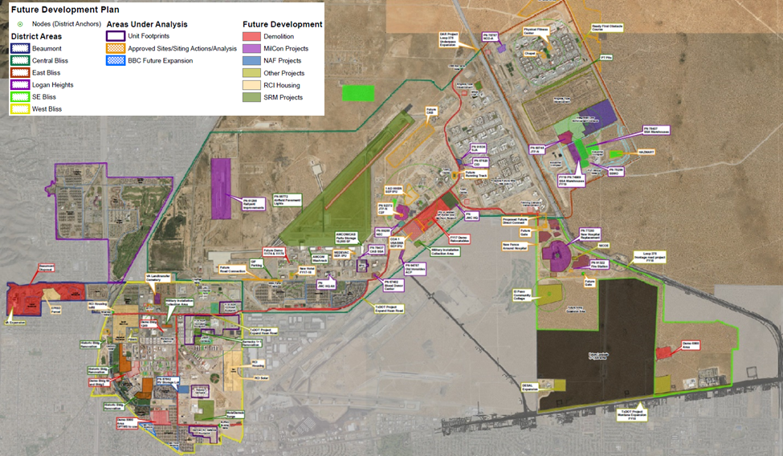
Figure C.1. [Institution Name] Future Development Map (2018 Master Plan)

–
Courses of Action Considered
This appendix provides a detailed description of each course of action (COA) considered for the [Installation Name] Installation Energy and Water Plan (IEWP). Section D.2 covers the COAs that will improve existing operations, plans, and procedures to ensure mission continuity in the event of an energy or water utility outage. Section D.3 presents the COAs that will reduce overall demand for energy and water (E&W) resources across the installation in order to reduce installation risk from higher resource demand, improve installation operational efficiency, and reduce the cost of any COAs requiring additional onsite E&W generation or supply. Section D.4 details COAs that will improve the condition of E&W infrastructure—with a focus on systems directly supporting critical facilities—to reduce the likelihood of utility disruption to those facilities. In Section D.5, COAs are presented that will enable [Installation Name] to improve its ability to sustain critical missions by increasing the capacity of E&W supplies to critical facilities.
Appendix A describes the process followed for identifying and documenting the COAs summarized below. Specifically, Section A.3 of Appendix A describes the process for generating these solutions.

Enhance Operations and Plans
[Installation Name] will enhance existing operations, plans, and procedures to ensure mission continuity in the event of an energy or water utility outage. The COAs and next steps described below will support this strategic objective.
[Below is one complete COA provided here as an example. Other COAs that may appear in this section include the following:
- Update and maintain generator list
- Develop generator refueling and service restoration plans
- Augment mobile power generator capacity
- Enhance utility planning and coordination
- Conduct annual readiness testing for energy and water disruptions
- Develop and maintain emergency response plans for utilities.]
[Important Template Note:
Within each COA in the subsections below, include the following subsections as listed below. (Write NA within the section if not applicable to the specific COA.)
- Project Locations
- Specifications
- Deficiencies Addressed
- Funding and Execution Options
- Next Steps
- Assessment Summary]

COA OP-1: Augment Mobile Power Generator Capability
[The following text is an example only. Replace this example with your installation’s COA.]
While most critical facilities on XXX are equipped with permanent backup generators, approximately 28 facilities do not have generators in place. Numerous facilities supporting the LRC maintenance division; Directorate of Plans, Training, Mobilization and Security (DPTMS) mobilization and training missions (simulators and range facilities); and other critical missions on XXX are not equipped with generators and will suffer mission degradation or failure during energy supply disruptions. For some of these facilities, mobile power generators can improve energy security, with the benefit of enabling the DPW to place power when and where it is needed.
Mission owners confirmed that functions performed in some facilities can withstand brief interruptions or are performed periodically and do not require continuous access to electric power. Where delayed power restoration is acceptable, portable generators may be effective options. Likewise, portable generators may be suitable where facilities have periodic energy requirements that depend on building occupancy or mission activities.

Project Locations
The project locations include facilities currently without auxiliary generators and planned facilities where a permanent backup generator is not approved or deemed necessary, but access to backup power may be required.

Specifications
Certain facility types are better candidates for mobile generators. Some facilities are only occupied or used during mission activities. For example, the LRC Deployment Readiness Reaction Facility may only be operational during railhead staging activities, and some of the missions associated with range testing only require facilities leading up to, during, and immediately following major test events. Other facility types may have multiple locations distributed across the garrison and in some cases can consolidate activities into a single building or smaller footprint. The child development centers (CDCs), youth centers, and dining facilities (DFACs) can be good candidates for mobile power where building occupancy can be transferred from one location to another depending on the nature and/or duration of the disruption.
While portable generators provide more flexibility than permanently installed equipment, DPW will need to consider additional planning requirements for portable generators:
- Mobile generation equipment will increase the complexity of operational and fueling logistics, requiring coordination and tracking of equipment deployment and status. Telemetry of mobile generator performance and fuel status is less likely to be available than for permanent generators, requiring manual verification.
- Staffing levels may need to increase to transport, operate, and maintain generators.
- Acoustic abatement and careful equipment placement will be necessary to minimize disruption to facility occupants from noise and emissions.
- Safety procedures and training will be necessary for maintenance personnel operating mobile equipment.
Buildings need to be wired with the appropriate connection points in order to take power from a mobile generation resource. Externally accessible power panels must be configured with switchgear that manually disconnects the building circuits from the utility transformer and accepts power output from the connected mobile generator. These types of transfer switch panels (often referred to as “quick-connect” panels) should be considered both for existing buildings and for renovations or planned new construction. In addition to electrical connections, concrete pads or parking facilities with sufficient space for positioning trailer-mounted generators and portable fuel tanks will be required.

Deficiencies Addressed
- Critical mission sustainment: A portion (or all) of the 28 facilities that do not have backup generators cannot be sustained during long-term interruptions.
- Critical mission risk reduction: Approximately 64 facilities lack permanent backup power sources and have no existing plans for auxiliary backup sources.

Funding & Execution Options
For building scale backup generation resources, programmed appropriated funding streams are the likely viable acquisition method. DPW may want to increase the number of mobile generators as part of the standard generator replacement process. Sustainment, restoration, and modernization (SRM) funding will be required for any facility retrofits to install quick-connect panels.

Next Steps
- Catalogue current fleet of mobile generators (including light carts); add entries to generator list with relevant information.
- Identify refueling equipment and protocols for any existing mobile generators.
- Down-select list of critical buildings that do not currently have generators that are candidates for mobile power hookup retrofits.
- Ensure that buildings going through military construction (MILCON) design process evaluate mobile power hookups as an alternative to permanent generators or as a backup power configuration.

Assessment Summary
COA OP-1: Augment Mobile Power Generator Capability
Priority Criteria | Summary
Risk reduction | CMS: Does not reduce risk of disruption but deployed resources can help sustain power to up 28 facilities lacking generators for longer-term outages
Risk reduction | CMRR: Provides flexible, deployable redundancy support to up to 64 facilities to speed recovery time
Risk reduction | IRR: N/A
Cost to implement | $100–800k for acquisition of new mobile equipment; mobile generator rentals from local vendors; additional costs for building quick-connects
Operational efficiency | N/A
E&W demand reduction | N/A
Funding sources | SRM, DPW (planning/procedures), MILCON (quick connects as part of building design and construction)
O&M impact | Centralized O&M at DPW yard reduces cost burden; comparable to O&M costs for existing permanent generators
Feasibility | Requires logistical support from DPW (trucks with trailers, personnel, refueling)

Reduce Demand
[The following text is an example only. Replace this example with your installation’s COA.]
[Installation Name] will reduce overall demand for energy and water resources across the installation with prioritization given to critical facilities, in order to reduce installation risk from higher resource demand, improve installation operational efficiency, and reduce the cost of any COAs requiring additional onsite E&W generation or supply.
[Below is one complete COA provided here as an example. Other COAs that may appear in this section include the following:
- Update water balance and implement water conservation measures
- Implement energy conservation measures
- Install utility meters on all critical facilities.]

COA RD-1: Optimize HVAC Building Controls for Energy Efficiency and Occupant Comfort
Optimize HVAC controls in critical facilities to minimize energy consumption and preserve occupant comfort. Suggested optimization measures can be completed through existing building automation systems (BASs) or manually, and include the following:
- Global HVAC temperature setbacks during unoccupied periods (nighttime, weekends, etc.)
- Zone temperature control via variable air volume / zone temperature scheduling and zone setpoint optimization
- Dynamic discharge air setpoints to match temperature scheduling adjustments
BAS optimization / re-tuning™ can be completed remotely within the Building Operations Control Center (BOCC) for the critical facilities connected to the Utility Monitoring and Control Center (UMCS). HVAC controls optimization should be completed for the remaining facilities, including either re-tuning™ of a local BAS and/or installing programmable thermostats to implement HVAC scheduling that better aligns with building or zone occupancy.
Connect buildings with local BASs to the BOCC as appropriate. Buildings with more savings opportunities should be prioritized. Energy-using equipment in centrally controlled buildings can also be turned off or reduced in the event of an anticipated outage or a partial outage to allow redistribution of loads or to avoid a blackout.

Project Locations
Building walkthroughs, UMCS screenshots, and Meter Data Management System (MDMS) analysis are all suggestive of significant and widespread opportunity for optimizing HVAC operational efficiency within critical facilities at XXX. While it was observed during the building evaluations that facilities tied to the UMCS tended to have larger optimization measures in place already (e.g., global unoccupied temperature setbacks), all critical facilities would benefit to varying degrees from a comprehensive re-tuning™ effort or the installation of programmable thermostats. The table below lists the facilities initially identified. Since not all critical buildings were visited onsite, some assumptions were made regarding the HVAC controls present at each building. For buildings not on the UMCS list, either local BAS re-tuning™ or installing/programming programmable thermostats is recommended.
Table D.1. Facilities Recommended for HVAC Controls Optimization
HVAC Control Type by Building
UMCS-tied BAS |  | Local-only BAS |  | Thermostat Only
54 | 11211 | 56 | 11108 | 2 | 11224

Specifications
Updating a facility’s BAS and using a central access point for equipment diagnosis and monitoring can provide both qualitative and quantitative benefits. There are qualitative benefits associated with resiliency, as well as O&M and occupant comfort benefits (listed in Table D.2 for standard BAS optimization elements). The BAS can be used for building load reduction in the event of an emergency to allow critical buildings access to available power, or during a planned event or outage (e.g., demand response programs, generator testing). It can decrease energy use of a facility’s HVAC system by zone or across the entire facility. Integrating additional building systems (e.g., lighting, elevators) yields the ability to further reduce energy loads as necessary. A BAS may even be used to monitor generator fuel tank levels.
Table D.2. Qualitative Benefits from BAS Optimization
BAS Optimization Element | Qualitative O&M Benefits | Occupant Comfort Improvements
Schedule adjustments (optimal start/stop, zone temperature setbacks, unoccupied zone temperature setbacks, heating and cooling enable/disable) | Reduced equipment runtime, which will extend equipment life and could reduce O&M. | Optimal start/stop considers outdoor air temperature, indoor temperature, previous startup/shutdown trends, along with occupancy schedule to enable the system to begin conditioning prior to occupancy so that the building is at set point when occupancy begins.  Proper temperature setbacks allow for mechanical systems to be enabled during the unoccupied hours to reduce indoor environment recovery times upon system startup without increasing overall energy consumption.  Heating and cooling enable/disable features will eliminate simultaneous heating and cooling to maintain occupant comfort level with reduced energy consumption.
Duct static pressure reset | Reduced demand on supply and return fans will result in extended motor life and fewer fan belt changes. | Lower duct noise will lead to increased occupant comfort and productivity.
Supply air temperature reset | Reduced demand on boiler/chillers and terminal reheat systems will extend equipment life and reduce O&M. | The indoor air supply will be discharged at a more comfortable temperature for the occupants.
Differential pressure reset | Reduced demand on circulation pumps and wear on valve seats will reduce O&M and extend equipment life, and reduced system pressure will decrease inadvertent heating/cooling through over-pressurized valves. | Reduce operating noise for the occupants and maintain existing occupant comfort level.
Chilled water / hot water temperature reset | Reduced equipment runtime will extend equipment life and reduce O&M. | Maintain existing occupant comfort level.
The quantitative benefits are gained from energy savings by implementing BAS optimization measures (re-tuning™) and by routinely monitoring the facilities for any equipment overrides. Re-tuning™ is a process that aims at minimizing energy consumption by identifying no- to low-cost efficiency improvements within the BAS. Table D.3 highlights the most common re-tuning™ measures that are applicable to these systems.
Table D.3. Quantitative Benefits from BAS Optimization
Description | Average Range of Expected Savings
Scheduling/Optimal Start: schedule building equipment to operate as needed to meet occupancy demands | 4%–5%
Zone Temperature: program appropriate zone temperature set points and setbacks with respect to the type of space and level of occupancy | 2% –3%
Static Pressure Reset: program a static pressure reset schedule based on building load | 1.5%–2.5%
Discharge Air Temperature Reset: program discharge air temperature reset based on feedback from zones being served | 1%
Hot Water/Chilled Water Temperature Reset: program supply temperature reset schedule based on either outdoor air temperature or building demand | 0.5%–1%
Hot Water/Chilled Water Differential Pressure Reset: program a differential pressure reset based on outdoor air temperature and average heating/cooling demand from the building | <1%
It is important that all BASs use the same brand and software version, and that an integration and naming standard for data points be created to ease the site-wide integration process and avoid cross-platform communication issues. DPW BAS staff and maintenance staff must be trained on the system and create a process to correct any HVAC issues, regardless of whether the issues are tenant complaints or mechanical failures. Cooperation and system knowledge are important for all BAS and HVAC staff to maintain the intent and integrity of an enterprise BAS system.

Deficiencies Addressed
- Critical mission sustainment: Fifty-one facilities have been identified as having excessive energy demand. Reducing demand in these facilities will enable them to more easily be sustained on existing resources.

Funding & Execution Options
Building controls measures generate cost savings that can be leveraged to improve the economics of other resilience projects when using utility energy savings contracts (UESCs), Energy Resilience and Conservation Investment Program (ERCIP), or other funding sources that are competitive based on savings to investment ratio (SIR). Utility modernization (QUTM) funds could be used to buy down the project to further improve cost effectiveness, such as for enterprise system integration.

Next Steps
- Verify all buildings connected to the enterprise BAS system are on the UMCS list.
- Verify HVAC control type for buildings not on UMCS list.
- Assess opportunity (HVAC control settings, performance) and level of effort/investment required for each building.
- Develop statement of work to include re-tuning™ of critical UMCS facilities, re-tuning™ of local-only BASs, installation and programming of programmable thermostats where pertinent, and connection of local-only BASs to the BOCC as appropriate.
- Ensure cyber security controls are included.

Assessment Summary
COA RD-1: Optimize HVAC Building Controls for Energy Efficiency and Occupant Comfort
Priority Criteria | Summary
Risk reduction | CMS: Reduces energy requirement of 51 facilities by 5%
Risk reduction | CMRR: N/A
Risk reduction | IRR: N/A
Cost to implement | $150k for controls updates (SIR 1.1), $480k to include integration of critical buildings with local BAS into enterprise system (SIR 0.4)
Operational efficiency | $90k annual cost savings  Demand response / load shedding capabilities could further reduce demand costs
E&W demand reduction | Electricity savings – 7,700 MMBtu/yr  Natural gas savings – 6,000 MMBtu/yr  Critical facilities energy use intensity (EUI) reduction – from 75 to 72 kBtu/ft²/yr  A test on 5 buildings suggested an annual savings of up to 9-10% per building could be achieved by implementing 2-degree setbacks during peak demand periods
Funding sources | UESC, QUTM, energy savings performance contract (ESPC), ERCIP  Bundle with less economic resilience measures
O&M impact | Requires some O&M to ensure optimized settings are maintained  Greater O&M required for buildings not on the enterprise system
Feasibility | XXX staff already manages BAS and can implement suggestions

Improve Infrastructure
[The following text is an example only. Replace this example with your installation’s COA.]
[Installation Name] will improve the condition of energy and water infrastructure—with a focus on systems directly supporting critical facilities—to reduce the likelihood of utility disruption to those facilities. This will be implemented through the following COAs.
[Below is one complete COA provided here as an example. Other COAs that may appear in this section include the following:
- Electricity
- Implement redundant electrical supply lines for critical areas
- Conduct a power quality and disruption assessment
- Install backup power systems on critical water infrastructure
- Repair and replace electrical feeders as needed
- Natural Gas
- Install redundant natural gas supply
- Install natural gas distribution lines to create looping
- Replace bare steel natural gas distribution line
- Water
- Assess distribution lines to prioritize repairs/replacements
- Install redundant drinking water supplies where applicable
- Install redundant chlorination equipment
- Upgrade lift stations for sewer bypasses
- Repair/retrofit booster stations as required.]

Electricity

COA INF-E-1: Conduct Circuit Interconnection Evaluation
Coordinate with RGEC to obtain circuit maps and accurate one-line diagrams of the XXX main cantonment electrical distribution system. Maps and diagrams need to show transformer sizes, circuits, and switchgear in order to evaluate current and possible redundant interconnections between substations, circuits, and feeders. RGEC has indicated they can provide the required circuit maps and one-line diagrams with approval from RGEC headquarters.

Project Locations
It is recommended that XXX, in coordination with RGEC, align the circuit maps and one-line diagrams with the installation facilities. This will ensure any recent construction is reflected on the maps and diagrams.

Specifications
It is recommended that XXX review the circuit maps and one-line diagrams, paying close attention to circuits and feeders supplying the facilities on the critical facilities list. It should be noted where redundancy of circuits and feeders currently exists, if transformer sizes are adequate for interconnection, and where the redundancy can be added to improve energy resiliency.

Deficiencies Addressed
- Critical mission risk reduction: RGEC did not provide circuit maps or one-line diagrams showing transformer sizes, interconnections, and switchgear. As a result, the capability/capacity of circuit and feeder redundancy throughout XXX and its ranges is unknown. Therefore, an evaluation of circuits and critical facilities lacking interconnections could not be conducted, affecting 50 critical facilities.
- Installation risk reduction: Lack of interconnection and redundancy of circuits and feeders puts all facilities at the installation at a greater risk for experiencing power outages.

Funding & Execution Options
UP Contract: It is anticipated the maps and diagrams should be provided through the current UP contract with RGEC. Any new/additional circuit interconnections are UP costs and projects for the capital improvement plan (CIPs).

Next Steps
- Coordinate with RGEC to receive circuit maps and one-line diagrams.
- Map locations of critical facilities within the circuit maps and one-line diagrams.
- Review circuit maps and one-line diagrams to evaluate current interconnections and redundancy capabilities for critical facilities.
- Prioritize critical facilities that do not currently have redundant circuits/feeders.
- Ensure future contractors stipulate circuit maps and one-line diagrams are to be provided to XXX and at a minimum updated annually.

Assessment Summary
COA INF-E-1: Conduct Circuit Interconnection Evaluation
Priority Criteria |  | Summary
Risk reduction | CMS: N/A
Risk reduction | CMRR: Addresses unknown circuit redundancy by identifying locations where circuit redundancy is lacking on main cantonment affecting 50+ facilities
Risk reduction | IRR: Contributes to enhanced emergency planning and contributes to the development of circuit redundancy projects, which can reduce the frequency and duration of outages
Cost to implement | Low to Medium cost ($-$$)
Operational efficiency | N/A
E&W demand reduction | N/A
Funding sources | Drawings and documentation should be provided per UP contract  Circuit interconnections are UP – CIP projects
O&M impact | Very modest O&M burden on EPE or RGEC would result
Feasibility | Evaluate interconnections: based on data availability  Establish new interconnections: TBD input from EPE and RGEC

Increase Capacity
[The following text is an example only. Replace this example with your installation’s COA.]
[Installation Name] will improve its ability to sustain critical missions by increasing the capacity of energy and water supplies to critical facilities. It will do this by implementing the following COAs.
[Below is one complete COA provided here as an example. Other COAs that may appear in this section include the following:
- Electricity
- Investigate utility-scale power plant on installation lands
- Add energy storage to existing renewables as applicable
- Investigate building microgrid and hybrid systems
- Investigate potential for substation centralized backup generators
- Enable islanding of substations as applicable
- Natural Gas
- Analyze potential for liquid natural gas
- Water
- Investigate alternate water sources
- Install distribution lines for looping
- Install cooling water storage for air-cooled HVAC.]

Electricity

COA CAP-E-1: Add Energy Storage to Existing PV Arrays
Augment existing large PV arrays with battery storage and interconnect them with critical loads to form microgrids that can be islanded.

Project Locations
The gym / main sub PV array is 2.25 MW. Isolating this circuit would allow the array to serve several critical facilities depending on the exact circuit configuration. An understanding of the circuit configuration is needed to determine exact isolation points for optimization of PV production for charging batteries and serving critical loads throughout the day and night. This islanding capability could be extended to a larger group of buildings if the three 1.5-MW generators were also incorporated.
The HQ array is 1.35 MW. This building already has backup generators and fuel storage sufficient to provide N+2 redundancy and 20–25 days of power to the facility during an outage. Connection to the neighboring PV array reduces the reliance on fuel; addition of a battery and more PV further reduces reliance on fuel. This fuel could then be used for other generators and boilers, or to serve additional loads in the HQ with generator reconfiguration. Alternatively, the array could be connected to other nearby loads that do not have existing backup generation.

Specifications
Similar to campus microgrids, using existing PV to form a microgrid can be accomplished with various component sizes. Additionally, the portion of the circuit served may be able to be altered to better match the existing PV capacity. For the locations discussed here, additional PV could be added or only the existing PV could be used, various battery capacities could be used, and generators are sized to carry the remaining load.
As an example, the HQ building was analyzed for generator fuel use and capital cost under various scenarios: base case (existing generators only), interconnecting existing PV, and interconnecting existing PV with options of adding more PV and/or adding a small or large battery. These options are graphed in Figure D.1, indicating fuel use over a 14-day outage and capital cost for each configuration.

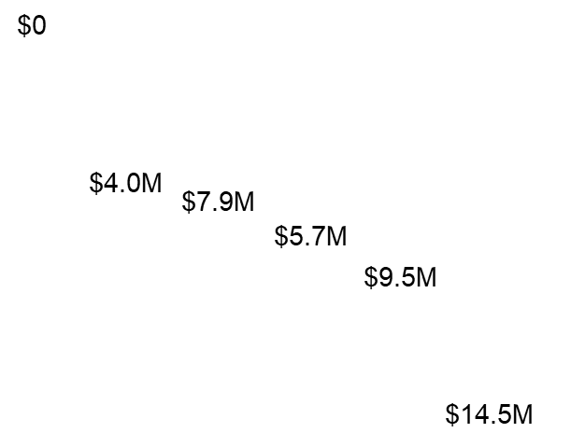
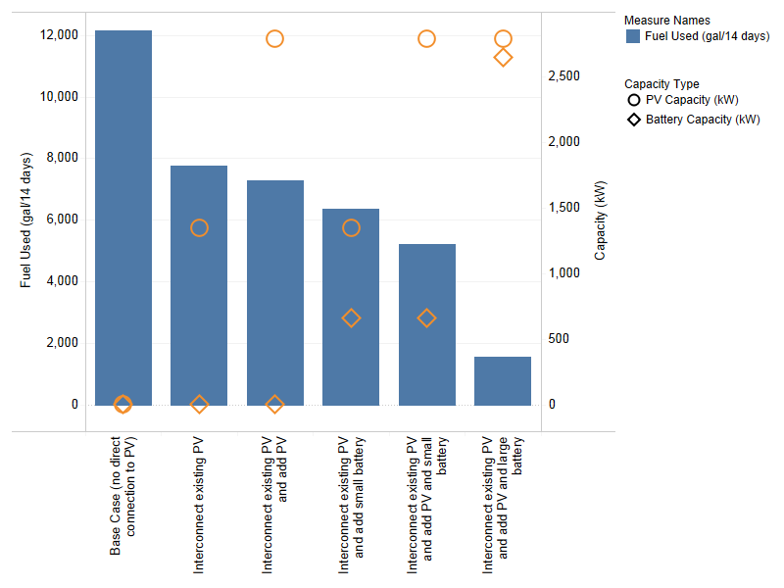
Figure D.1. 14-Day Fuel Use and Capital Cost for HQ Microgrid Configurations

Deficiencies Addressed
- Critical mission sustainment: There is inadequate backup capacity to sustain facilities near the existing PV arrays. A microgrid will establish backup power while reducing the fuel requirement for diesel generators at groups of facilities, depending on the location.
- Critical mission risk reduction: There is a lack of redundant power for groups of facilities near the existing PV arrays.
- Installation risk reduction: The duration of installation outages is unacceptable. The installation’s capacity to generate power onsite is insufficient. There is no ability to island critical facilities.

Funding & Execution Options
The existing PV arrays were installed through the ESPC contract. Changing the interconnection points will require modification of the ESPC contract, and thus the entire microgrid could be incorporated into that modification. Alternatively, UESC or ERCIP funding could be used, just as with a campus microgrid, and potentially QUTM funds to buy down the project.

Next Steps
- Obtain one-line diagrams for the circuits to which the PV arrays are connected.
- Outline the benefits and challenges of connecting each PV array to neighboring loads and choose one location for an initial microgrid. Define the microgrid boundary.
- Discuss the potential for contract modification with the ESPC contractor.
- Obtain interval data for the buildings to be included (preferably 1 year of data).
- Analyze options and make preliminary design decisions.
- Pursue funding.

Assessment Summary
COA CAP-E-1: Add Energy Storage to Existing PV Arrays
- Priority Criteria | Summary
Risk reduction | CMS: Provides backup capacity for CMS
Risk reduction | CMRR: Provides backup power for critical facilities
Risk reduction | IRR: Reduces outages at facilities, increases onsite supply capacity, and provides ability to island
Cost to implement | Location dependent: $4M–$10M+ per array  $2,000/kW ($500/kWh) for Li-ion storage; $2M+ for microgrid infrastructure
Operational efficiency | Firm reduction of contract demand: under curtailment, energy storage can optimize dispatch and reduce grid requirements, TOU arbitrage
E&W demand reduction | N/A unless more PV added
Funding potential | Modify existing ESPC contracts, ERCIP, UESC
O&M impact | Ongoing O&M can be integrated with existing PV and/or substation maintenance activities
Feasibility | Technically feasible, interconnection and islanding add complexity. Possible challenges if contract mods are required.

–
Implementation Plan Development
The assessment team’s first step in developing the implementation plan for the IEWP was to select the best-performing proposed solutions. The team prioritized facility solutions based on mission impact analysis; they prioritized installation solutions for risk reduction potential, and prioritized demand-reduction solutions based on life-cycle cost. The remaining solutions were then assembled into a single matrix with basic evaluation criteria (scored and color-coded red, amber, and green) as follows:
- Contribution to Risk Reduction (not scored). All solutions must reduce risk as a first consideration, but those that reduce risk in more than one area (CMS, CMRR, IRR) or reduce risk for multiple critical facilities, should be considered a priority over those that do not.
- Cost to Implement (not scored). A rough order of magnitude was used to identify low ($); medium ($$), and high ($$$) cost solutions.
- Operational Efficiency. Green = More efficient operations and/or allows for peak shaving, O&M budget reduced as a result of this solution; Amber = No change, negligible, or slight increase to O&M budget; Red = Increase to the O&M or utility bill as a result of this solution.
- Energy and Water Demand Reduction. Green = significant reduction in energy and/or water use; Amber = No or slight decrease in consumption; Red = Increase in energy load, water use.
- Funding Potential. Green = There are existing funding options; and/or solution is life-cycle cost effective; Amber = There are few ways to get funded; Red = No funding known or highly improbable to find a funding source.
- O&M Impact. Green = No additional O&M burden; Amber = Moderate additional O&M burden; Red = Significant additional O&M burden.
- Feasibility (Technology, Regulatory, People). Green = No significant barriers; Amber = Barriers in one or two areas; Red = Significant barriers in all three areas.
The results of this preliminary prioritization became the basis for the [Installation Name] IEWP Solutions Workshop, held at [Installation Name] on [Insert date]. The agenda for the session included an overview of the IEWP purpose and goals, a review of the mission critical facilities, and a review of deficiencies identified. The solutions were then presented to the stakeholders for feedback. Attendees for the Solutions Workshop are presented in Table E.1. During the same onsite visit, the assessment team also presented the classified E&W Security assessment findings. The classified spreadsheet was provided electronically to [Installation Name] by SIPRNet as “Appendix F, CLASSIFIED Findings” for storage and updating by the garrison team. The [Installation Name] Garrison Command reinforced that solutions should be prioritized based on the level of support provided to their overarching MFGI mission.
Table E.1. Solution Workshop Attendees
Name | Organization | Email
[An example follows. Revise this paragraph as needed per your site-specific approach.] Based on the feedback from the stakeholders at the workshop, some slight modifications to the critical facilities list were made. The team also revisited the list of solutions to prioritize based on the role the facility plays in support of the MFGI mission. The final, prioritized implementation plan (see Section 4.0) was prepared to reflect these changes as well as a request by the installation that the execution step responsibilities be specified to the extent possible to help with allocation of limited staff resources.
The resulting prioritization of COAs is summarized in Table E.2. This table also illustrates how each COA contributes to the risk reduction, demand reduction, and other criteria established by [Installation Name] at the outset of the [year] assessment. More detail on how the proposed COAs affect each of these criteria can be found in the assessment summary table for each COA.
Table E.3 summarizes the different potential funding sources for each COA documented in Appendix D.

Table E.2. Preliminary Solution Prioritization Table
 |  | Risk Reduction Contribution |  |  | Cost to Implement | Oper.  Efficiency | E&W Demand Redn. | Funding Sources | O&M Impact | Feasi-bility | Priority
 |  | CMS | CMRR | IRR |  |  |  |  |  |  | ❶ | ❷ | ❸
Operations and Plans
OP- | Operations and Plans COA Title(s) | No | 42 | No | LC/NC |  |  |  |  |  | ❶
Reduce Demand
RD- | Reduce Demand COA Title(s) | 89 | No | No | $ |  |  |  |  |  | ❶
Improve Infrastructure: Electricity
INF-E- | Electric Infrastructure COA Title(s) | No | 50 | Yes | $ |  |  |  |  |  | ❶
Improve Infrastructure: Natural Gas
INF-N- | Natural Gas Infrastructure COA Title(s) | No | 20 | No | $$$ |  |  |  |  |  |  |  | ❸
Improve Infrastructure: Water
INF-W | Water Infrastructure COA Title(s) | No | 38 | No | $ |  |  |  |  |  | ❶
Increase Capacity: Electricity
CAP-E | Electric Capacity COA Title(s) | Yes | Yes | Yes | $ |  |  |  |  |  | ❶
Increase Capacity: Natural Gas
CAP-N | Natural Gas Capacity COA Title(s) | 15 | 15 | No | $$$ |  |  |  |  |  |  |  | ❸
Increase Capacity: Water
CAP-W | Water Capacity COA Title(s) | 15 | 15 | Yes | $$$ |  |  |  |  |  |  | ❷

Table E.3. Potential Funding Sources for Courses of Action Identified
 | Funding Potential Key: | Best Source | Moderate Potential | Low Potential | No Potential
COA# | Course of Action
COA# | Course of Action | Funding Method A | Funding Method B | Funding Method C | Funding Method D | Funding Method E
Operations and Plans
OP-X | Operations and Plans COA Title(s)
Reduce Demand
RD-X | Demand Reduction COA Title(s) |  |  |  | g
Improve Infrastructure Condition: Electricity
INF-E-X | Electric Infrastructure COA Title(s) |  |  | g
Improve Infrastructure Condition: Natural Gas
INF-N-X | Natural Gas Infrastructure COA Title(s) |  |  | g
Improve Infrastructure Condition: Water
INF-WX | Water Infrastructure COA Title(s) |  | g | g
Increase Capacity: Electricity
CAP-E-X | Electric Capacity COA Title(s)
Increase Capacity: Natural Gas
CAP-N-X | Natural Gas Capacity COA Title(s) |  |  | a | r | r
Increase Capacity: Water
CAP-W-X | Water Capacity COA Title(s) |  |  | a | a | a

–
CLASSIFIED Findings
The classified results were provided electronically to [Installation Name] by SIPRNet as “Appendix F. CLASSIFIED Findings” to [Classified results POC] for storage and updating by the garrison team.

Facility-level meter data (Meter Data Management System [MDMS]) were used where available and reliable: MDMS data were used to develop natural gas consumption profiles for 31 buildings. Available consumption data were extrapolated as needed.
Building walkthroughs were conducted at a total of 33 buildings. For each of these, audit data were used to estimate water use as well as to generate a Facility Energy Decision System (FEDS, www.pnl.gov/feds) model of the building. FEDS models were used to develop hourly electricity profiles. A PNNL-developed plumbing tool was used to develop water usage profiles.
This method was applied using metered or modeled JBLM buildings, Commercial Buildings Energy Consumption Survey data, and the Construction Engineering Research Laboratory - Engineer Research and Development Center’s Water Use Intensity at U.S. Army Facilities data to estimate the electricity, natural gas, and water usage for the remaining critical facilities.
In addition to the mission buildings identified above, there are other buildings that are not authorized to have permanent backup generators per Unified Facilities Criteria (UFC) 3-540-01 and/or AR 420-01 (Section 4-67) such as DFACs or CDCs.

